School of Medicine: Study Leave Guidelines

Yorkshire and the Humber Deanery

Workforce, Training and Education, Yorkshire and Humber, NHS England

Background
All schools in Yorkshire and the Humber Deanery adhere to the overarching NHS England guidelines on Study Leave. The national policy, Y&H Operational Study Leave Guidance, Accent Leave Manager (ALM) User Guide, FAQs and support contacts can all be found on our website. PGDiTs should familiarise themselves with the study leave process in conjunction with the information below before making an application for study leave time and / or funding.
This guidance outlines the pathway for the financial administration of the Study budget allocated to Y&H NHSE School of Medicine (SoM). It builds upon the Y&H Operational Study Leave Guidance and National NHSE Study Leave policy and references General Medical Council recommendations.
The SoM Study Budget is available to support the training and development of PGDiTs in Medicine from IMT1 to CCT. The General Medical Council (GMC) have indicated that curriculum delivery should be, primarily, through local specialist training programmes (STP) and ‘on-the-job’ education, with reliance on courses to be minimised where possible. No training course can any longer be considered ‘mandatory’ for completion of training. All training is to be considered on an individualised basis through high quality educational supervision.
On occasion it is accepted that course attendance will be required, usually in areas of subspecialist training, which may not be available within the local training programme or clinical services. Additionally, some PGDiTs may request training outside of, or in addition to, that required within the curriculum, as part of enhanced personal development. For clarity, the Study budget is primarily designed to address the delivery of the curriculum and associated competencies, rather than to fund discretionary training outside of this. Applications for Discretionary leave and / or funding will be considered based upon funding availability and educational appropriateness relevant to the applicant’s training pathway.
The following documents the relevant pathways for PGDiTs to request funding support from the study budget.

Principles
- IMT and HST PGDiTs are entitled to 30 days of SL per annum.
- Requests for additional study day(s) will be considered only if appropriate to training.
- There is ‘no cap’ to the number or value of courses any PGDiT can apply for; each study leave episode applied for is considered on its own merit.
- ‘Some activities not required to achieve curriculum outcomes may not be approved and/or be part funded’.
- LTFT PGDiTs and academic PGDiTs have equitable access to SL time and funding.
- Attendance should be as close to the placement site of the PGDiT as possible.
- High quality locally delivered activity is preferred where possible. It is strongly suggested that Specialist Training Committees (STC) consider the development of local or virtual training courses where possible.
- All funding must be linked to curriculum requirements and the PGDiTs personalized development plan (PDP).
- PGDiTs on OOP are not eligible for SL, except for OOPT (Training).
- Requests for non pre-approved courses may be approved with Postgraduate Dean (PGD) discretion. A detailed explanation of exceptionality will be required.
- PGDiTs in a ‘Period of Grace (POG)’ are ineligible for funding. However, individuals can receive time for ensuring revalidation requirements are met.
- Parental leave - The entitlement to SL continues and this may be taken during ‘KIT’ days or will otherwise accrue to be taken at a later date.
- Service delivery must be maintained. PGDiTs must ensure that appropriate cover is available to maintain clinical service and patient safety. Before making an application in Accent Leave Manager (ALM), PGDiTs should contact their hospital rota coordinators at least 8 weeks in advance to secure approval for the time away from service.
- Exam fees are not funded; one private exam study course (per exam) would usually be funded.
- ALS will only be funded by NHSE for PGDiTs in specialties where ALS is a curriculum requirement. The usual upper limit for reimbursement will be £300. However, Deans discretion will apply where due to uncontrollable factors the cost is higher, or a two-day course is required. It is likely that PGDiTs will require 2 ALS courses over the duration of their training. PGDiTs are encouraged to undertake the blended delivery ‘e-ALS’ for first time candidates and recertification for future attendance. This is the only course where more than a single course will be routinely funded.
- International conferences /meetings – Reasons for funding support would include PGDiTs presenting significant findings of their research or attending training courses not available in the UK. For approved international study leave applications, NHSE will consider funding either the full cost of the course/conference fees or the full cost of economy travel and accommodation whichever is the lower amount. When the course/conference fee is waived by the course provider, NHSE will consider funding the full cost of economy travel and accommodation.
- Funding for postgraduate qualifications will only be considered under exceptional circumstances
- A pre-approved list of courses has been generated through discussion with PGDiTs and TPDs. These reflect courses that are required to fulfil the curriculum/decision aid and whereby expertise cannot be gained within STP.
- PGDiTs should be aware that only a single course of a single type (excluding ALS) will be provided.

Process
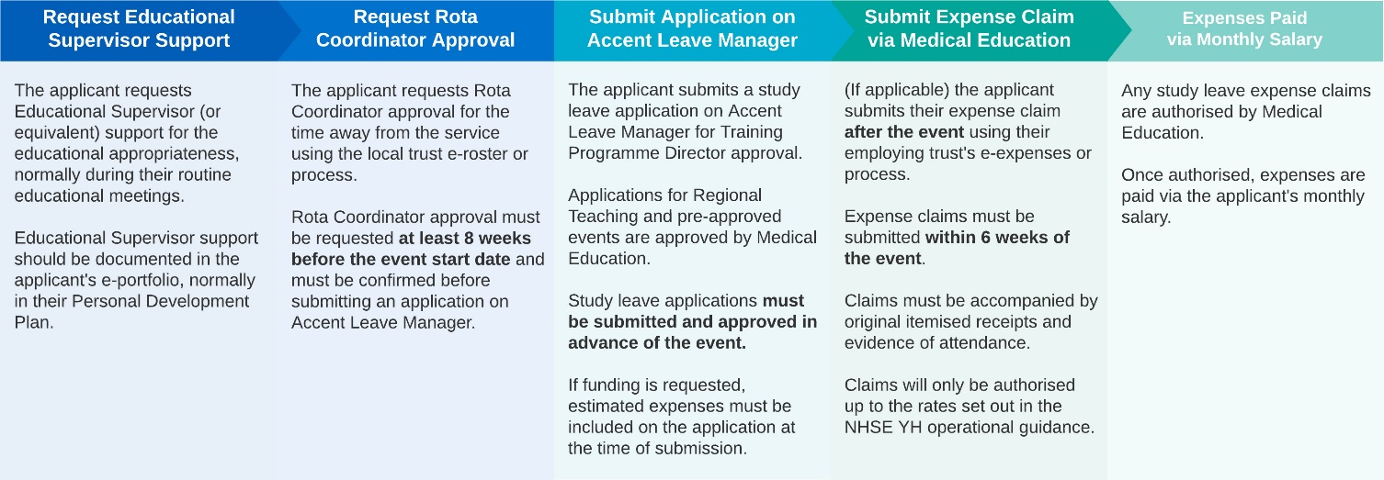
- The PGDiTs will determine, through development of a PDP at their initial ES meeting, their annual training requirements, and will identify the mechanisms by which such training will be delivered. Any training not documented in the PDP will not be financially supported.
- If training needs cannot be met through service level training NOR STP (over the cycle of training) a course can be considered.
- ES should discuss all methods of attaining competence, including personal study, attendance at specialist clinics and MDTs outside of the local environment (including virtual attendance), use of online resources etc before considering a paid course.
- Only if a course is considered the only method of achieving the required competence should a course be considered.
- The PGDiT should source such course (local preferred) with costs and discuss with ES.
- SL application should be submitted via Accent Leave Manager (ALM). For pre-approved activity the request will be directed to Medical Education Department at NHSE Y&H who will process the application.
- If the activity is not on the pre-approved list (i.e. TPD exception request) the PGDiT should utilise the supporting information free-text box within the ALM application to provide rationale for their request. .The statement should outline why the request is:
- Required (for curriculum competencies or decision aid ARCP progression) and included in their PDP
- Cannot be delivered without a course (should demonstrate that there is no other reasonable way of attaining the training) AND
- Demonstrate cost effectiveness of course suggested – local/distance
- Confirmed with the rota coordinator to be possible whilst service provision is maintained
- The ALM application will be directed to the TPD for consideration. The TPD will then either:
- Forward the application to the relevant deputy Head of School (dHOS) with supportive correspondence. The request will be discussed in HOS Operational Meeting (HOS, dHOS, programme support team) with the benefit of sight of the curriculum delivery budget and a decision will be cascaded thereafter to the PGDiT, via ALM (or)
- Reject the application and where necessary making alternative suggestions. PGDiTs should not pay for, nor attend, any course without approval as retrospective applications will NOT be reimbursed.
- All pre-approved courses will be available on the Maxcourse booking system. PGDiTs are expected to book, and pay for the course, in full, being aware of any cancellation policy.
- An attendance certificate and all receipts will be required.
- Reimbursement of any approved expenses will be though the employing Trust expense systems (not via the Deanery).
- Trusts will reimburse costs using local processes. Please note Trusts are only permitted to authorise expenses to the value approved within the ALM application and to the nationally agreed rates for travel and subsistence. An outline of the current rates can be found in the NHS T&Cs and within the YH SL Operational Guidance.
- Trusts will re-charge the Deanery for any authorised expenses.
- PGDiTs must not attempt to submit expenses which exceed those outlined on the approved ALM application.
- PGDiTs in financial hardship may ask for special dispensation/funding. Evidence of financial hardship will be required.

