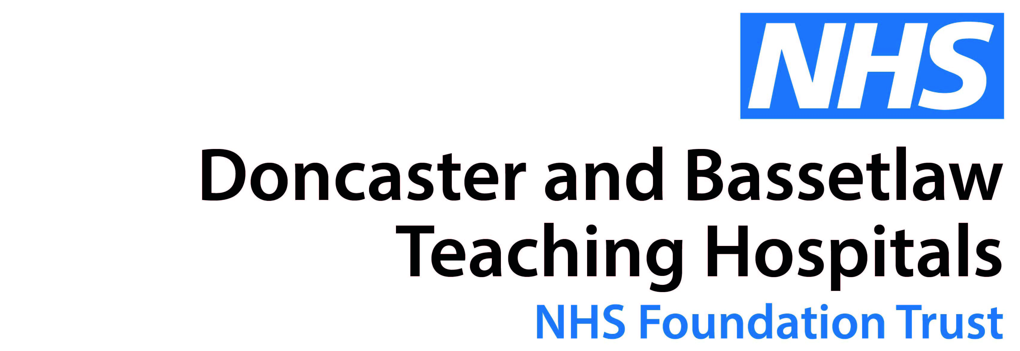

SAS Obstetric Airway and Emergencies Simulation Training Day

For Anaesthetic and Obstetric SAS Doctors only

Places are limited with a minimum of 4 place and a maximum of 6 place per specialty

Friday 24 May 2019
Simulation Centre, Montagu.

5CPD Points

Please email hazel.maloney@nhs.net to book a place

