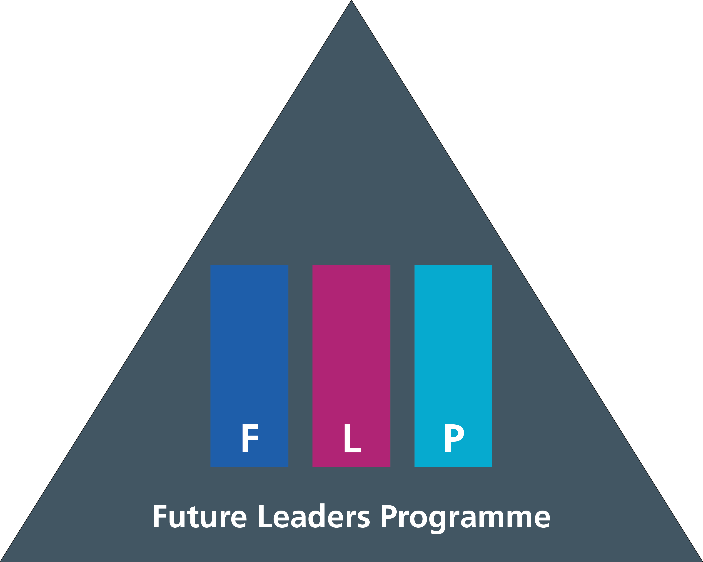
Future Leaders’ Programme Learner Agreement & Personal Development Plan

This document should be completed jointly between the Leadership Fellow and their Educational Supervisor
Completed forms should be signed and returned to futureleaders.yh@hee.nhs.uk within 4 weeks of starting in post.

Expectations of the FLP year are outlined in the Fellows Handbook. There is typically a 50:50 split between the project work and supplementary learning through academic study and personal reflective development. It is recommended that expected work arrangements (in-person/hybrid/remote and flexible/asynchronous hours) and project specific details such as learning objectives and outputs are discussed when completing the learner agreement and formulating the personal development plan (PDP).

Learner Agreement
To be completed by the Leadership Fellow

- I recognise that by undertaking the Future Leaders’ Programme, I am expected to contribute and engage with the wider FLP cohort
- I commit to the specific behaviours expected of me during my post, as outlined in the FLP Charter
- I have completed a PDP which recognises giving equal priority to project work and personal/professional development, including exploration of my own ‘Equality, Diversity and Inclusion’ learning journey
- I agree to provide feedback, both during and at the end of my post which support the further development of the programme to meet the needs of myself and others
- I have read and signed the policy on undertaking locum work, bank work or clinical sessions whilst on the Future Leaders Programme

Signature of Leadership Fellow:

Name:

Date:

To be completed by the FLP Supervisor/Line Manager

I confirm that I have discussed the expectations above with the Fellow who I am responsible for and agree the aims and objectives set out in the personal development plan below. I confirm that they will be provided with support to achieve these and will be released for personal and professional development activities. I will support the Fellow in reviewing these objectives regularly. I will also support the Fellow by facilitating a discussion to explore and identify their learning needs around equality, diversity, and inclusion.

Signature of FLP Supervisor:

Name:

Date:

Signature of Line Manager (if applicable)

Name:

Date:

Personal Development Plan
You should think about your PDP in terms of overall aims, project-specific and personal development objectives. When outlining objectives structure these using SMART goals (Specific, Measurable, Achievable, Relevant, Time-bound). Further information on goal setting can be found on MindTools.

Your PDP may evolve over the course of the year as pieces of work come to an end and new opportunities arise. You should review your PDP on a regular basis and may wish to consider keeping notes on your progress within this document for the purpose of mid-year and end of year appraisal.

We recognise that Equality, Diversity and Inclusion are important leadership topics, and we would encourage you to consider your own learning needs in relation to this.

Aim = What you hope to achieve.
Objective =The action(s) you will take in order to achieve the aim
(Reference: Solent Online Learning)

Overall Aims

Project Specific Objectives
Be realistic in what is achievable, focus on depth and quality in relation to your own personal capacities.

What is my goal? How will I achieve this? By when?

Personal Development Objectives
What is my goal? How will I achieve this? By when?

Equality, Diversity & Inclusivity
The FLP recognises that many of our NHS colleagues with protected characteristic experience discrimination, exclusion, and barriers which can make progressing in their careers even more challenging. The FLP aims to develop compassionate leaders who recognise, respect and truly value the need for equity, diversity and inclusion in healthcare. It is widely recognised that diversity within the workforce and inclusive cultures which value the contributions of all colleagues is linked to increased productivity and innovation, and ultimately, better care for patients.

It is important for each of us to recognise that we are all at different stages of learning in relation to EDI. Consider your own feelings towards these issues using the following questions as prompts. Use these to formulate learning objectives specific to developing your own inclusive leadership practices.

- What does equality, diversity and inclusion mean to you?
- How well do you perform as an inclusive leader currently? How might you develop inclusive team practices as part of your project?
- What privileges and biases do you recognise in yourself?
It is imperative that Fellows, and their Educational Supervisors, have a grasp of the importance of EDI as a leadership issue, as well as awareness and understanding of the FLP values. The FLP Charter was co-created by the 2021/22 cohort of Fellows to make the ethos and values of the programme clear, and to outline the attitudes and behaviours expected of Fellows.
- What behaviours and practices can you implement to build workplace inclusion?
- What additional training do you need to tackle the issues you have identified?

You may also want to consider HEEs guide to embedding inclusive objectives, which is part of wider work on distributed leadership for inclusion.

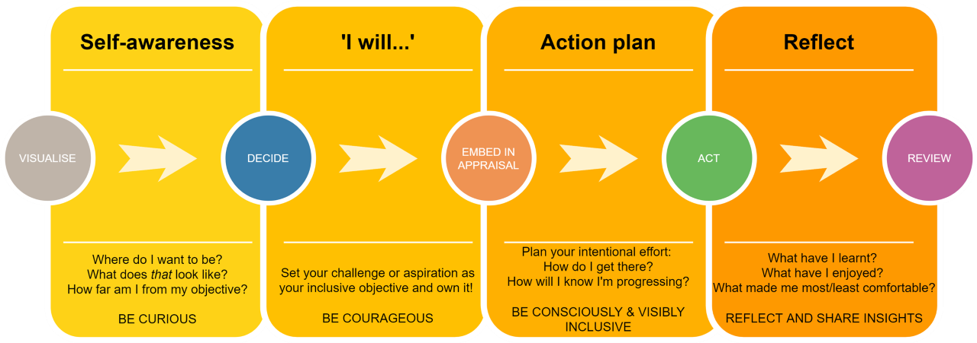

What is my goal? How will I achieve this? By when?

Consider scoring your current level of competence in the following aspects of ‘Inclusive Leadership’. You may wish to revisit this throughout your FLP year.

The Key to Inclusive Leadership, Bourke & Titus

- Visible commitment: They articulate authentic commitment to diversity, challenge the status quo, hold others accountable, and make diversity and inclusion a personal priority.
- Humility: They are modest about capabilities, admit mistakes, and create the space for others to contribute.
- Awareness of bias: They show awareness of personal blind spots, as well as flaws in the system, and work hard to ensure a meritocracy.
- Curiosity about others: They demonstrate an open mindset and deep curiosity about others, listen without judgment, and seek with empathy to understand those around them.
- Cultural intelligence: They are attentive to others’ cultures and adapt as required.
- Effective collaboration: They empower others, pay attention to diversity of thinking and psychological safety, and focus on team cohesion.

(Reference: Harvard Business Review, 2020)

Inclusive Leadership Competency Radar

Ranking System
Score | Skill Level | Descriptor
5 | Expert | Fully capable and experienced  Sought for help by others  Needs no assistance to complete tasks  Demonstrate ability to lead and train others
4 | Proficient | Capable and experience  Demonstrate proficiency  Able to work independently with little help
3 | Demonstrating | Able to perform above basic level  Has some direct experience  Need help from time to time
2 | Basic | Limited in ability or knowledge  Need significant help from others
1 | Low | Little experience
0 | None | Unable to perform

