Yorkshire and Humber IMG Peer Mentoring Scheme
Guide for Peer Mentees
Contents
Yorkshire and Humber IMG Peer Mentoring Scheme 1
1. Registering for Peer Mentoring 3
2. About MentorNet 3
3. Creating a MentorNet account 3
3.1 Profile information 3
3.2 Personal Statement 4
3.3 Account approval 4
4. Logging in to MentorNet 4
4.1 Logging in with a browser 5
4.2 Using the MentorNet app 5
5. Updating your profile 5
5.1 Editing your profile information 5
5.2 Uploading a photo 6
6. Changing your notification settings 7
7. Site appearance 7
8. Selecting a mentor 8
8.1 Viewing mentor profiles 8
8.2 Requesting to match with a mentor 9
8.3 Responding to your match request 9
9. Starting the mentoring relationship 9
10. Messaging in MentorNet 10
11. Recording mentoring sessions 10
12. Sharing documents 11
13. Concluding the mentoring relationship 12
14. Peer mentoring resources 12
15. Troubleshooting MentorNet problems 12
15.1 Unable to log in 13
15.2 Forgotten password 13
15.3 Not receiving automated emails 14
16. Support 14

- Registering for Peer Mentoring
You can self-register for the peer mentoring scheme through our online system, MentorNet.
- About MentorNet
MentorNet allows you to view the profiles of potential mentors and request to match with them. Once you are matched with a mentor, MentorNet allows you to easily manage your mentoring relationship, including maintaining communication and keeping notes.
- Creating a MentorNet account
To choose a peer mentor, you will need to create a MentorNet account.
You will be asked to read and sign the Privacy Notice and Consent Agreement before you can access the system. These notices tell you what your rights are under data protection legislation; they explain how your personal data will be used and who you can contact if you want to correct any mistakes or withdraw your consent. Nobody can access any of your personal data, and you cannot access the system, until you have accepted the Privacy Notice and given your consent.
When creating your account, any information you provide that is denoted with a padlock () is not publicly visible. These are private fields, and this data can be seen only by you and by system administrators. Your mentor and other users cannot see this information.
  - Profile information
After providing your personal information, you will be asked to complete your profile. You will need to provide your:
- School/Specialty
- Employing Trust
- Training Grade
- Country of origin
- Trusts you have previously worked in
- Your current training site
- Gender/gender identity
- Preferred pronouns
- Date of birth
  - Personal Statement
You will also be asked to complete a ‘personal statement’, which acts like a biography that will be visible to your mentor once you have matched with them.
When writing your biography, think about the information your mentor might like to know about you. In the least, we recommend you include:
- Why you are seeking peer mentoring
- Areas of the support and/or advice you are looking to receive
- Any restrictions on your availability (i.e. days and times of the week you will or won’t be available)
- Your preferred format of meeting (i.e. which virtual meeting platform you would like to use or any face-to-face locations you would be happy to meet)
- Any interest/hobbies or additional information you feel comfortable sharing which may help your mentor get to know you better
  - Account approval
Once you have self-registered, you will be unable to access the system until the account has been approved by the Peer Mentoring Administrator. You will receive an email notification when your account has been approved, after which you will be able to log in to MentorNet and access the register of Peer Mentors.
- Logging in to MentorNet
When you log on to MentorNet, you are taken to an account dashboard which provides any updates that have been shared within the system, such as news and resources, as well as any unread messages.
  - Logging in with a browser
MentorNet can be used within any common browser, including Microsoft Edge, Google Chrome, Firefox and Safari, and it has been designed to be mobile-friendly.
To log in, please visit: https://hee.sfgmentornet.com/
We recommend saving the URL as a browser favourite, to enable easy future access.
  - Using the MentorNet app
You can also download the MentorNet app for your smart phone in the Google Play Store or Apple's App Store.
- Updating your profile
Once your account is approved, you should review your profile information and update it if needed. We also ask that you upload a photo of yourself to make your profile more personal and allow your matched mentor to recognise you.
  - Editing your profile information
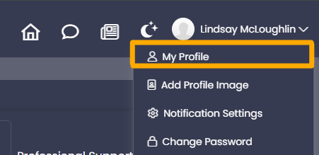
To edit your profile, click on your name in the top right-hand corner of the screen and select ‘My Profile’:

When your profile page loads, click the ‘Edit’ option underneath your name:
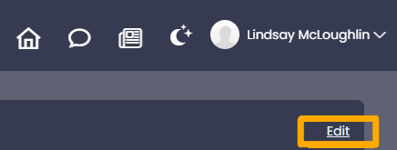

From this page you can expand each profile information tab and update your details. Once you have made the required updates to your profile, click ‘Confirm Changes’ in the top right corner of the page.
  - Uploading a photo
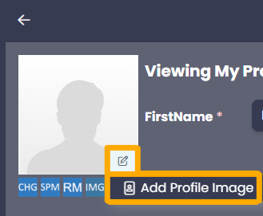
To upload a photo, click on the pencil icon in the blank user image and select ‘Add Profile Image’:

Please remember that peer mentoring is a professional relationship, so we encourage you to use a headshot style photo of yourself. If you do not have a headshot and are unable to take one, please choose a photo where you are clearly visible and nobody else is in the picture.
- Changing your notification settings
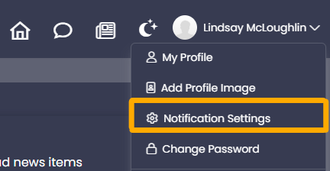
You can amend your email notification settings at any time by clicking on your name in the top right corner and selecting ‘Notification Settings’:

From here, you can change the types and frequency of email notifications you receive. We recommend keeping the standard notification settings to ensure you don’t miss out on key information and communications, both from the Peer Mentoring Administrator and your mentees.
If you download the MentorNet app, you will be able to update your notification settings within the app and/or your phone’s settings.
- Site appearance
You can toggle MentorNet between a light theme and a dark theme, depending on your preference and accessibility needs.
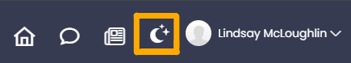
To change the theme, click on the ‘Appearance’ icon next to your name in the top right corner:

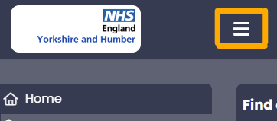
You can also show or hide the side menu bar by clicking on the ‘Toggle Sidebar Menu’ icon next to the NHS England logo:

- Selecting a mentor
We use a mentee-led matching process for the Peer Mentoring Scheme, which allows you to request to match with your chosen mentor.
  - Viewing mentor profiles
To view the profiles of all available peer mentors, click on the ‘Find Mentor’ menu option:
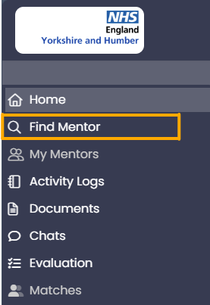

You will automatically be shown a list of all available peer mentors who have capacity to take on a new peer mentee. You can either browse this list of available mentors and view their profiles to identify a match, or you can use the search function to identify available mentors that meet certain criteria. To do this, expand the ‘Search Criteria’ bar at the top of the page:
You can either search using standard matching keywords that mentors have selected or input your own keywords.
Standard matching keywords are options peer mentors can select when creating their profile. They include experiences or characteristics mentees may look for in a mentor.
You can also input your own keywords based on your specific needs, for example if you are looking for support with a specific theme or scenario. Where you input your own search terms, the system will search the entire user profile of all available mentors and will find all mentors who have these keywords anywhere within their user profile. We recommend using broader search terms and multiple phrases rather than anything too specific, in case a mentor has used different phrasing in their profile.
  - Requesting to match with a mentor
Once you have identified your preferred peer mentor, you can request to match with them. On their profile, click the ‘Request Match’ button.
Once you have chosen your preferred Mentor, click the “Request Match” button. A small pop-up window will open, allowing you to enter a message to the mentor that will be submitted alongside the match request. This is optional, but you may wish to enter a message that explains why you have chosen them as a mentor.
When you press submit, the match request will be emailed to your chosen peer mentor.
  - Responding to your match request
Peer mentors can accept or reject your match request. We anticipate they will reject a match request if they are temporarily unavailable (for example, imminently going on annual leave) or they have identified a conflict of interest which would make it unethical for them to act as your mentor. Should your request be rejected, you can submit a new match request for a different peer mentor.
Peer mentors are expected to respond to a match request within five working days. If you haven’t received a response after a week, please contact the Peer Mentoring Administrator for support: england.coaching.yh@nhs.net.
- Starting the mentoring relationship
When your match is accepted, you and your mentor will receive automated emails confirming the match and inviting you to contact each other. Your mentor will be able to view your profile once you have matched.
We expect the mentor to make first contact, which they should do by sending you a message within MentorNet.
- Messaging in MentorNet
Messaging in the system works in much the same way as messaging in most social media apps.
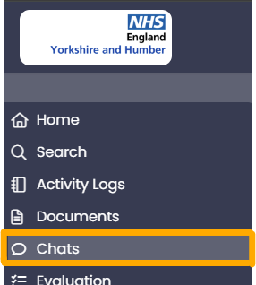
You can access your messages by clicking on the ‘Chats’ tab:

If you have any unread messages, there will be a coloured highlight next to the menu option, with the number of unread messages.
All your messages with a mentor are grouped into a conversation. If you click on the conversation, you will see a list of all the messages with your mentor, and you are able to reply. You can save draft messages to return to later.
When you receive a message in MentorNet, you will be notified by email.
- Recording mentoring sessions
You can have up to four sessions with your peer mentor. Each session should be recorded in MentorNet, and it is the responsibility of the mentor to record the meeting by creating an activity log. The activity log provides a summary of the meeting for you both.
When an activity log has been created, you will receive an email notification, and you have the option to add your own notes to it within MentorNet. Nobody else should add any additional notes to the activity log, only you.
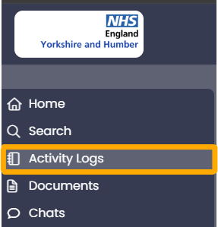
You can access and view your activity logs at any time by selecting the ‘Activity Logs’ option in the side menu and clicking on the log you wish to open:

- Sharing documents
You can share documents with your mentor within MentorNet and they can share documents with you. For example, if there is something you wish to share for them to review before your next meeting so it can be discussed.
To upload documents, access documents you have previously uploaded, and access documents shared with you, click on the ‘Documents’ tab in the side menu:
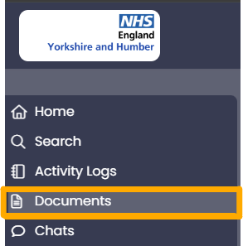

All shared documents will be visible on this page, showing the document name, the file type, the name of the document sharer and the date of sharing.
To upload a document, click ‘Upload Files’ in the top right corner. Once uploaded, the document will automatically be accessible to your mentor.
The only people that can view your uploaded documents are you, your mentor and system administrators.
- Extending the mentoring relationship
Peer mentors should provide a maximum of four sessions with mentees. Extending the relationship beyond these four sessions should only be requested in exceptional circumstances, and approval must be provided in advance of organising any further sessions.
Requests to extend the mentoring relationship must be submitted to the Peer Mentoring Administrator via england.coaching.yh@nhs.net. We will ordinarily only permit an additional two mentoring sessions.
- Concluding the mentoring relationship
Once all four mentoring sessions have taken place and are recorded on your activity log, your mentor will close the mentoring relationship within MentorNet.
Once closed, you will automatically be emailed a form requesting feedback on your peer mentoring experience. Please ensure you provide feedback to support the professional development of your peer mentor.
- Peer mentoring resources
You can access all peer mentoring resources within MentorNet, including the Ethical Framework and Code of Practice and a copy of this guide, by clicking on the ‘Resources’ tab in the menu bar:
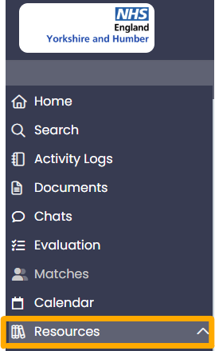

- Troubleshooting MentorNet problems
Should you experience any problems with using MentorNet, please refer to this guide to see if it provides a solution to your issue. If it doesn’t and you still require assistance, please contact the Peer Mentoring Administrator at: england.coaching.yh@nhs.net
  - Unable to log in
If you cannot login to your account, the most likely reason is that your username or password is incorrect, or your account has been locked. For example, if you enter your password incorrectly 5 times then your account will be locked.
If you cannot log in, please check you are using the right username and double-check your password is correct (check caps lock is off and check any upper/lower case characters – sometimes a lower case “L” can look like the number “1” or the letter “I”). If you still cannot ‘log in’ then contact the Peer Mentoring Administrator.
If your account has been locked, please email the Peer Mentoring Administrator to unlock your account.
  - Forgotten password
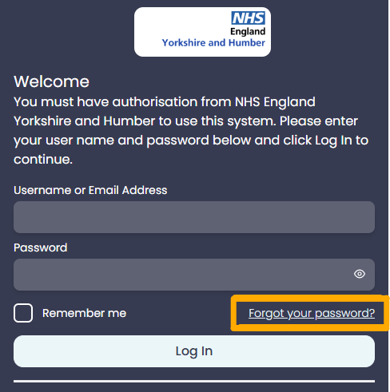
If you forget your password, click on the "Forgot your password?" link on the login page:

You will be asked to enter your username and to confirm the email address registered to your MentorNet account. A new password will then be sent to the email address registered. If this is the incorrect email address, you will need to email the Peer Mentoring Administrator and request they reset your password.
  - Not receiving automated emails
If you are not receiving any of the automated system emails, the most likely reason is they are going into your spam/junk folder. Check the following:
- Check the email address on your user profile is correct
- Check your spam/junk folders
- Check your MentorNet profile notification settings
You should also add the email address (noreply@sfgmentornet.com) to your ‘safe senders’ list in your email system to ensure future messages are not put into your junk/spam folders. You can find guidance for doing this in Outlook account on the Microsoft website. For any other email systems, you will be able to find instructions by searching for ‘adding a safe sender to Google mail’ in a search engine. If you use a different email provider, i.e. Yahoo, please amend your search accordingly.
- Support
Should you require support with using MentorNet that isn’t addressed in this guide, please contact the Peer Mentor Administrator at: england.coaching.yh@nhs.net.

