**1. How to interact with your Educational Supervisor**

Your Educational Supervisor (ES) will be allocated at the start of your placement and it is likely you will have the same one at the Hallamshire Hospital for the majority of your training, although when you are in the peripheral units you will have an ES from that unit too. You need to “choose” them on your eportfolio for them to be able to get access to the portfolio to see how you are progressing.

They are a critical friend to support you in setting your educational goals and seeing that you achieve the targets that have been set. They often also act as a mentor, an assessor and a source of help and career advice.

**When should I meet my ES?**

You should meet with your ES within the first 2 – 3 weeks of each placement to set your Personal Development Plan (PDP) for the next 6 months. This meeting will take at least 30 mins and they may want you to fill in a form in advance to think about the issues you will discuss. ***See Appendix 1***

Educational goals should be SMART:

**S**pecific: eg. Learn how to accurately measure intraocular pressure

**M**easurable: eg. Have this assessed as a CRS by 2 separate assessors

**R**ealistic eg. You are not expected to laser a retinal hole within your first 6 months in the job!

**T**imely: eg. Do this within 4 weeks of starting the job

Once you have decided on a PDP you should upload it on your Eportfolio

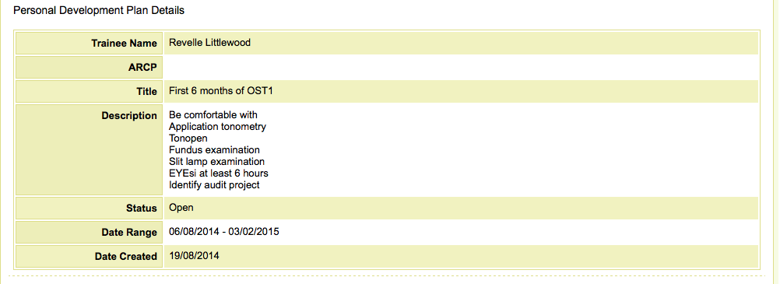

This is an active document and you can close each target as you achieve it. Doing so in this way is a good way to show evidence of how you are progressing.

**2. How will I know what is expected of me every year?**

Details of exactly what is expected of you in each year of training are on the Royal College of Ophthalmology Website. Follow the links:

<http://curriculum.rcophth.ac.uk/assessments/rita_guide>.

OST Curriculum > Assessments > ARCP Guidance > “What do I need to do during OST1?”

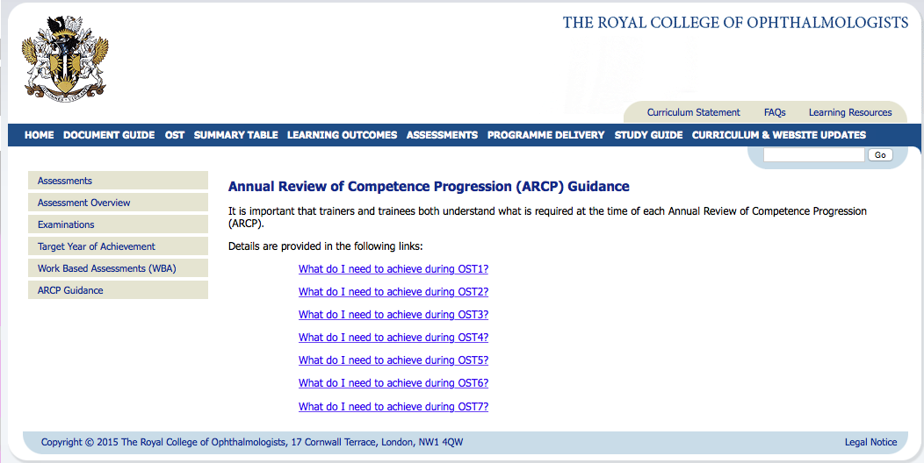

This will give you details of all the assessments and competencies needed for the year. It would be a good idea to look at this before your first meeting with your ES.

Most of the requirements for ST1 are practical skills like tonometry, assessed with a Clinical Rating Scale (CRS) as is taking a clinical history but there are some practical skills like Ocular Irrigation that are assessed with a Direct Observation of Practical Skill (DOPS) and some tasks like using the operating microscope that are assessed with an Objective Assessment of Technical Skills (OSATS) and you will also have to do a minimum of 10 Case Based Discussions (CBDs) talking through a clinical case, discussing your findings, your clinical plan and wider issues to do with management or findings in similar cases, with a more senior doctor (often a Consultant but possible a trainee at least 2 years more senior than you.) CBDs are very good learning experiences and 10 is a bare minimum.

You will need at least 1 Multi Source Feedback (MSF) per year. You need to keep a log of your surgical activity. There is an expectation that you will be involved in 1 audit per year and involved in research and publications during the course of your 7 years, sufficient for you to have a good chance of being appointed as a Consultant at the end. You need to have a reflective learning diary reflecting on what you have learnt during your Postgraduate teaching sessions (PGT) and on and courses you undertake with study leave.

***See Appendix 2 for the OST1 requirements***

**3. How often do I have to meet with my ES?**

You may well have several informal meetings with your ES and you can go to them at any time if you are having any difficulties but you MUST meet with them formally about half way through the year to review your progress and set goals for the second 6 months and you MUST meet them in advance of the ARCP (Annual Review of Competency progression).

**At 6 months**: they are going to want to look at your eportfolio (your ES, the TPD and the College Tutor are the only ones, other that you, who have access to your eportfolio.), they will want to see your logbook and they will need to see Clinical Supervisor Reports from all the Consultants you have been working with during the last few months so you need to have contacted your Clinical Supervisors and requested these in advance of the ES meeting.

In preparation for this visit you need to complete Part A of the Educational Supervisor’s Report (ESR) as your ES will need to complete the rest of Part B1 once they have seen your documentation. You need to update your PDP after this meeting and upload the completed ES Form onto your portfolio.

***See Appendix 3 for ESR***

***ESR 4.tiff***

**Prior to ARCP:** You need again to complete an updated Part A of the ES Form and your ES will complete part B2 and this should be uploaded to the eportfolio. Your documents MUST be fully completed and uploaded on the portfolio more than 1 week before ARCP and so your ES meeting should be well before this to make sure you have time to address any potential problems. Please note that the ARCP is usually late May/early June so in year 1 there is less than 12 months to complete the required competencies and you should probably be meeting your ES in early May. This means organising your MSF and requesting Clinical Supervisor reports in plenty of time. You need to complete Part 2 of the ESR before this meeting so that your ES can complete their section after reviewing your evidence of competencies. Your ES should be able to tell you what your expected Outcome at ARCP will be after this meeting.

**4. How do I interact with my Clinical Supervisors? (CS)**

It is good practice to meet with each of your CS before or at the start of the placement to find out about what the attachment entails, what is expected of you and what you should be getting out of the attachment educationally. The more advance preparation you do in terms of reading around the subject and anticipating what is expected of you, the more you will get out of the process.

It might also allow you to identify research or audit projects that could be completed during the placement. You will need to do several CBDs with your CS during the placement so

You will need some assessment of competency from every clinical attachment, usually a Clinical Supervisor’s Report (CSR) for but if your attachment is a surgical one, for example cataract surgery, then an Objective Structured Assessment of Technical Skill (OSATS) might be more appropriate than a CSR. It is much better to use the electronic CSR, which can be electronically signed, than the paper version.

***See Appendix 4 for CSR***

***CSR1.tiff***

**5. How to do a CBD**

Choose a case that you have been involved with, especially something that you have learnt from. The College suggest that 50% of cases should be chosen by the trainee and 50% by the Consultant. One way to achieve this would be to suggest 2 possible cases to your Consultant and ask them to choose. Sometimes Consultants will choose a case that they feel you might learn from or you might choose a case that has been complicated or where you felt out-of-your-depth. You will learn more from your failures than your successes. Make sure that you have the clinical notes and, if possible that your Consultant can see them in advance. Make an arrangement with the Consultant to meet and set aside at least 30 mins of uninterrupted time. Find a place where you will not be interrupted. Read around the subject before the meeting. Use it as a learning process to widen your knowledge.

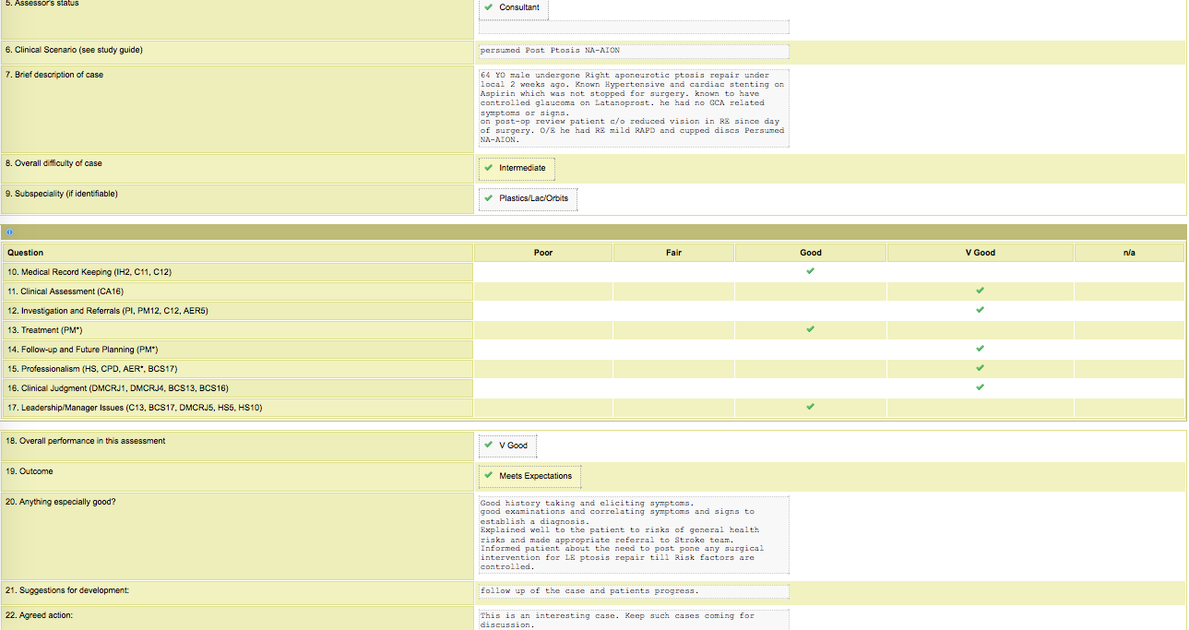Try and space your CBDs throughout the year. Never do more than 2 on any 1 occasion. Make sure you cover the curriculum of your current placement as you may not have another opportunity to do that sub-speciality again. Either complete your form with the CS or upload your version online immediately afterwards, for them to approve. A CS may not remember the discussion more than a week after the meeting and might decline to approve your form if you send it late. Make sure the suggestions for development and the action plan are filled in at the end.

**6. Clinical Assessments**

* OSATS = objective structured assessment of technical skills
* DOPS = Direct Observation of Procedural Skills
* CRS = Clinical rating scale

There are different requirements for each year again use the link below to see the requirements <http://curriculum.rcophth.ac.uk/assessments/rita_guide>.

The idea of clinical assessments (CRS, OSATS, DOPS etc) is not to perfect them completely before you ask for assessment but rather to get assessment relatively early in the learning process, as you will learn a lot more that way and have areas to improve upon and practice before you have them assessed again. An assessment where you have not met met the required standard should still be uploaded but is not a “failure” but an opportunity to learn and improve. Your assessor does not necessarily have to be a Consultant but does have to be someone completely competent at the task they are assessing for example senior trainees, nurse practitioners, orthoptists etc. As for CBDs, the completed form should be either done together or uploaded by you immediately afterwards for the assessor’s approval. If your assessor is not on the approved list of College Assessors, you need to discuss this with your ES or the Training Programme Director (TPD).

Either complete your form with the Assessor or upload your version online immediately afterwards, for them to approve. An assessor may not remember the discussion more than a week after the meeting and might decline to approve your form if you send it late. Make sure the suggestions for development and the action plan are filled in at the end.

Assessments have to be uploaded onto the eportfolio and ultimately associated with an ARCP (see below)

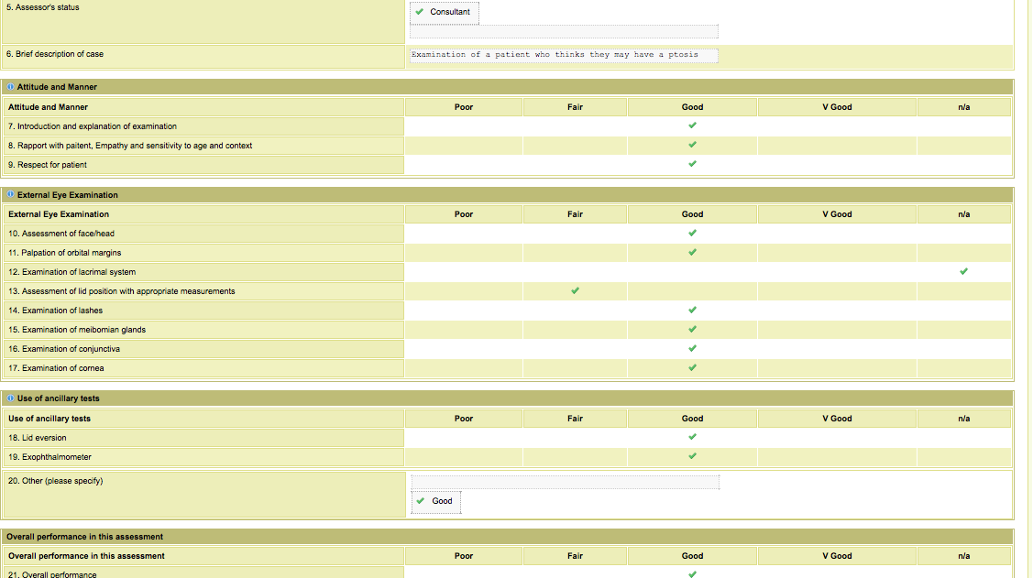

**7. How to upload documents onto the eportfolio**

When you upload something as a ‘resource’ on the portfolio, title it well! ie with a *date*, *what it is* (eg CS form) and *something relevant* (eg Mr X). Be systematic.

For something to be seen by your ARCP panel, it has to be assigned to the current ARCP. Sometimes the portfolio does it automatically, other times it doesn’t.

Associate as you go along. At the end of your training, you have to have amassed evidence for every curriculum point. After an ARCP is finished, you will not be able to make associations for those assessments. Don’t associate things that aren’t evidenced by the assessment.

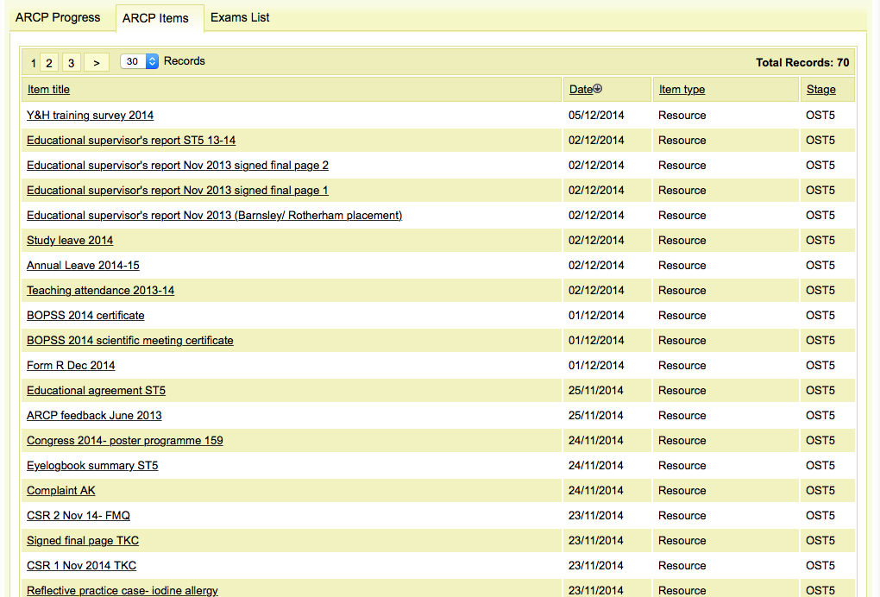

If you do an assessment that is required for a higher ST level: When you enter a new assessment the first box is ‘Please select the stage for this Assessment:’ It will then tell you your current level. DO NOT just fill in your current level. Fill in the level at which the college requires you to be signed off for that particular task, that might mean you are filling in ST7 when you are an ST1, which feels really weird, but it is the only way you will be able to link it to your ARCP when you are ST7 or whatever. Leave it unlinked to an ARCP until you are at the relevant stage of training.

e.g. removing corneal suture is ST2 competency. If you are ST1 and you do this assessment, fill in OST2 as the stage for the assessment. Associate it as normal, but do not assign it to an ARCP. When you are ST2, then assign to your ST2 ARCP.

To make your eportfolio easy to read for assessors at the ARCP (like the TPD or Head of School) link all the items for the ARCP close to the time of ARCP so that they can be organized in a logical and easy to follow way, for example, all the Clinical supervisors reports together.

To be reminded of what is required for each level, follow this link: <http://curriculum.rcophth.ac.uk/assessments/rita_guide>

If you have already entered the wrong training level, email [portfolio@rcophth.ac.uk](mailto:portfolio@rcophth.ac.uk) and ask them to correct it for you.

**8. Keeping a surgical logbook**

You are expected to keep a record of all surgery you are involved with or perform. You will be using eyelogbook.co.uk available through the College of Ophthalmology and it will be the most detailed recordIt of the spectrum of your surgery. It will send you weekly emails and it is important to keep it up to date. If the Medisoft surgical data has been correctly completed, it is also possible to get a record of all surgery you have been involved with through the Audit section of Medisoft.: Tools>Audit>Reports and Graphs>Operation date (set limits)>General (or select particular surgery eg. Cataract)>Summary Reports and graphs>List of patients operated on.

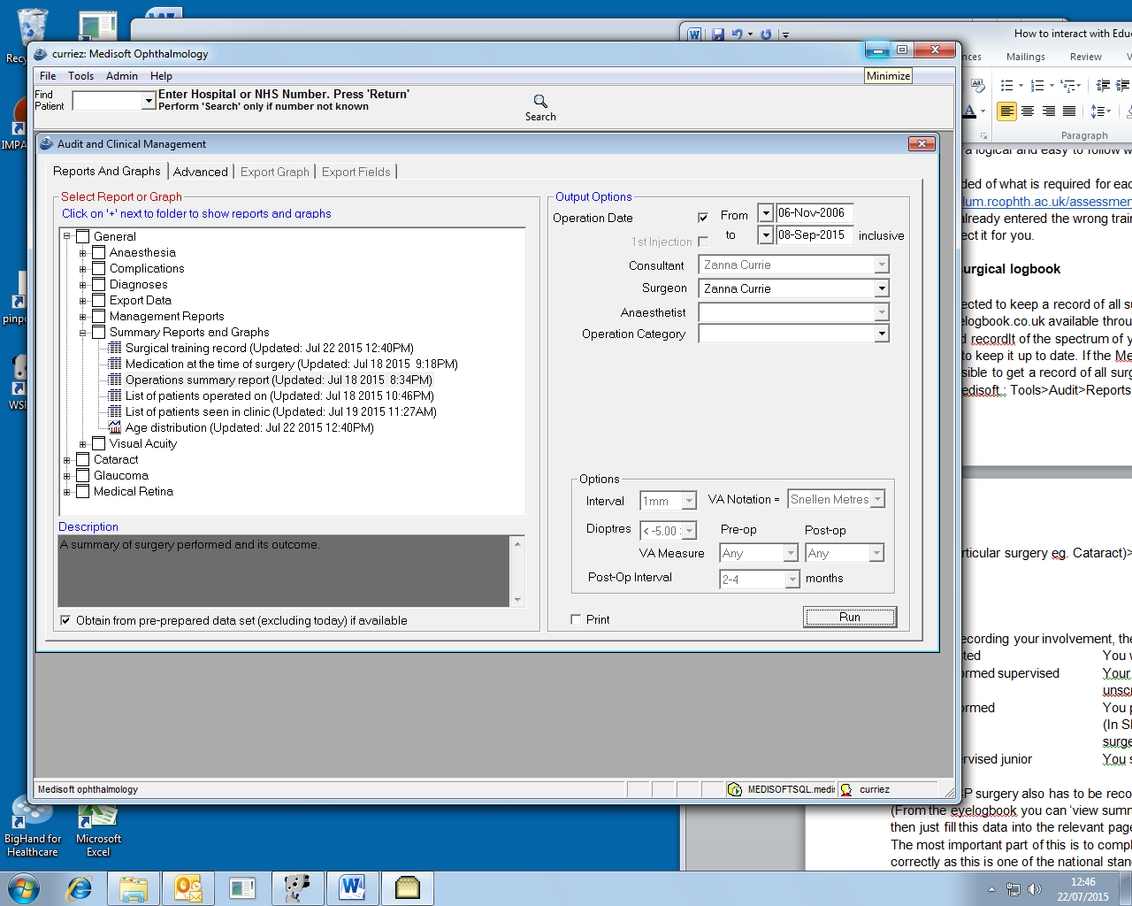

Medisoft can be used to produce graphs of refractive outcomes, look at complication rates and much more, BUT it depends on the accuracy of the inputting and it is best to keep up-to-date with your own cases.

In terms of recording your involvement, there are some strict rules:

A Assisted You were scrubbed and took part in surgery

PS Performed supervised Your supervisor was present, scrubbed,

unscrubbed or in the room

P Performed You performed without your supervisor present

(In Sheffield this will not practically happen for cataract

surgery until you are a signed-up principal)

SJ Supervised junior You supervised the training of a trainee.

For the ARCP surgery also has to be recorded on the ES form Part A .

(From the eyelogbook you can ‘view summary’ and filter ‘group by RCOphth category’ and then just fill this data into the relevant page

The most important part of this is to complete the Posterior Capsule Rupture Rate (PCR) correctly as this is one of the national standards for ophthalmologists. 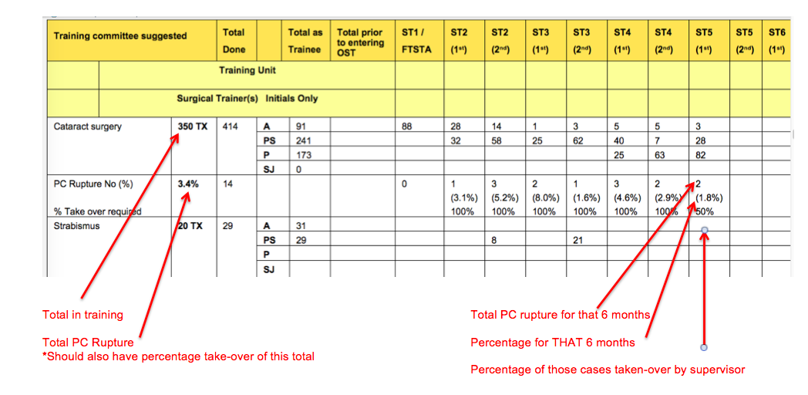

There is an expectation that trainees will manage more of their complicated cases as they get ore senior and this form shows that progression.

It is really important that you learn from cases that have not gone well. Recording all your cases with video lets you go back and look at them with a surgical trainer afterwards and bring them to teaching sessions for discussion. You are expected to follow them up and find out their final outcomes and completing a reflection about them on your portfolio might be appropriate.

**9. How to organise an MSF**

Multisource feedback should give you a picture of how you are doing from a variety of your colleagues, these can include nursing staff, clerical staff or secretaries, your fellow trainees both those at the same level and more senior trainees for example the rota organiser and it must contain a selection of consultants. You can have up to 15 assessors but need a minimum of 11 and it is sensible to choose more than 11 in case someone does not participate in the process. You need to upload the email address of all your assessors and your selection of assessors has to be approved by your ES before it can proceed. The MSF will close after 1 month or whenever all have replied, if this is sooner so set up the process well in advance of your pre-ARCP ES meeting to allow any concerns raised to be addressed.

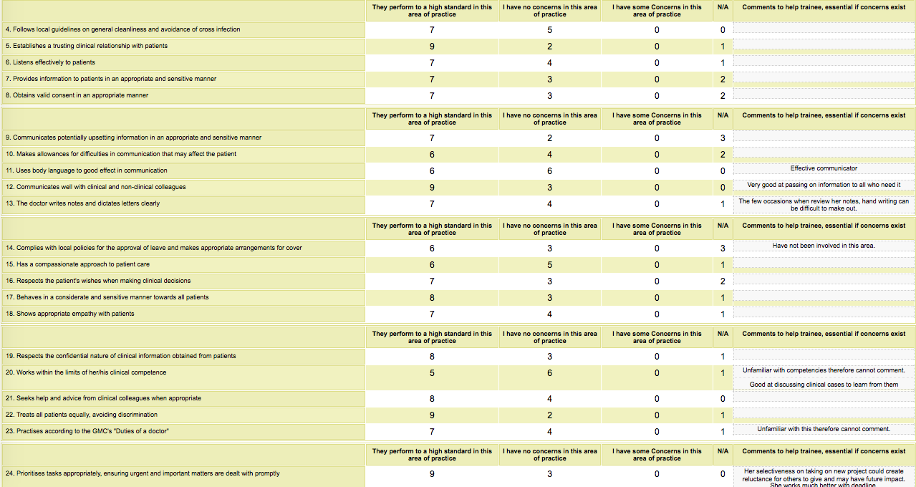

**10. How to use the Eportfolio as a record of reflective learning**

The portfolio can be used as a record of all your learning both formal and informal. For each Postgraduate Teaching session or all study-leave events there should be an entry in the ‘Events’ section of the portfolio. This allows you to categorise the type of event internal, external, self-accredited, managerial (one of the more difficult to show evidence for) and it allows you to reflect on what you have learnt.

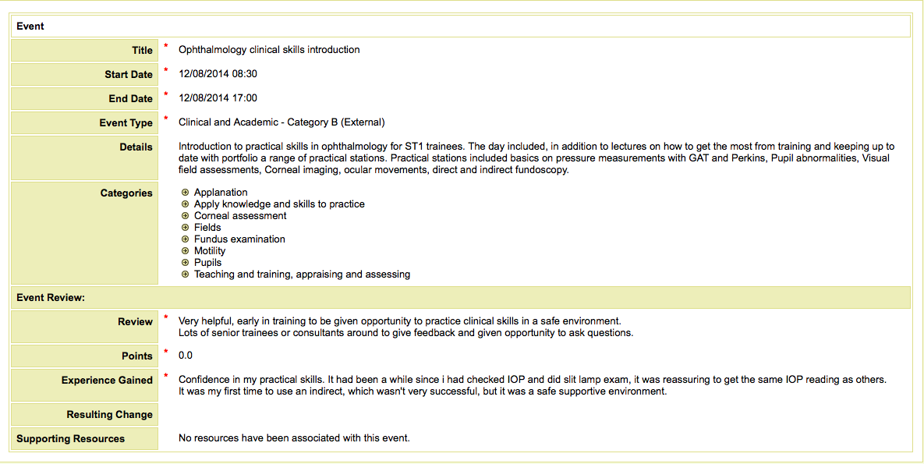

You can also use it to document your own learning, for example reading a journal article or learning from a clinical event.

