# How to Access Neurodiversity eLearning on Blackboard

If you already have a Blackboard Account, skip to Enrolling onto a course.

If you have already enrolled onto the course and want to access it directly from Blackboard, skip to Accessing the Course in Blackboard.

## Creating a Blackboard Account

1. Go to the [Create an Account page of Health Education and Learning Portal](https://hee.blackboard.com/webapps/bbgs-cloud-portal-BB5f7c558815e16/app/portal/register?locale=en&dir=ltr) (HELP) which is our booking platform for Blackboard courses.
2. Enter your email address, agree to the terms of service, and click submit:

1. You will be sent a security token to the email address you provided:

1. Return to the web browser, enter the security token and click submit:

1. Fill in the requested personal information to create your Blackboard account. **Please note** **the password requirements specified on this page are incorrect. Your password must be at least 12 characters long and contain at least one capital letter, at least one number and at least one special character/symbol**:

1. Your account has been created. Click Login to access the course catalogue:

## Enrolling onto a course

1. [Sign into the Health Education and Learning Portal](https://hee.blackboard.com/webapps/login/?action=default_login&new_loc=/webapps/bbgs-cloud-portal-BB5f7c558815e16/app/portal?locale=en&dir=ltr) (HELP).
2. You will automatically be taken to the Course Catalogue. In the search bar, enter ‘Neurodiversity’. The available courses should automatically show on the page:

1. Click on the image of the course you wish to enrol onto:

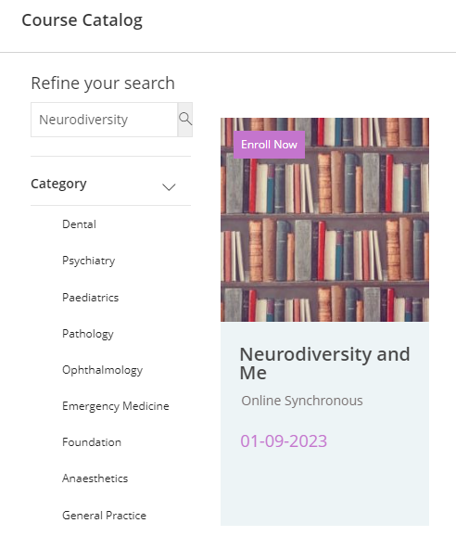

1. Click Enroll Now:

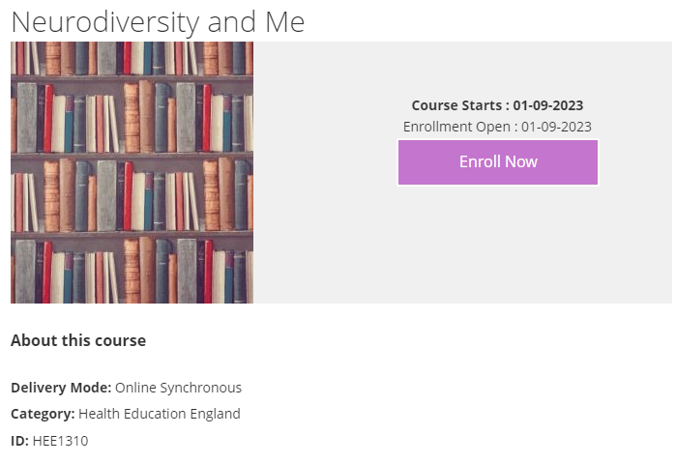

1. A pop-up box will appear to confirm successful enrolment. Click on Go to My Dashboard:

1. To open the course in Blackboard, click on Continue Course:

1. You can now access the course content in Blackboard:

## Accessing the course in Blackboard

1. After enrolment, to access the course via Blackboard, [log into Blackboard](https://hee.blackboard.com/).
2. Click on Courses:

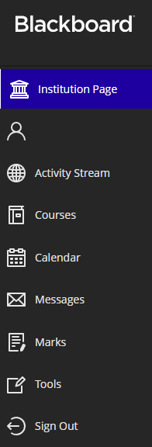

1. Click on Open beneath the course name:

1. You can now access the course content:

