 | Region (Deanery) Name | Yorkshire and the Humber
 | Title of post  Type of Training & duration of post | DCT1/2 Oral and Maxillofacial Surgery- based at Rotherham  12 month post
 | Training unit/locations | The Rotherham NHS Foundation Trust (Main Site)  Mexborough Montagu Hospital (Day Surgery Unit and Consultant Clinics)  Royal Hallamshire Hospital (Oncology Surgery)
 | Rotational Post information  and Duration | This is not a rotational post  12 month post
 | Full address of unit/s where training is based | The Rotherham NHS Foundation Trust  Moorgate Road  Rotherham  S60 2UD  Mexborough Montagu Hospital  Adwick Road  Mexborough  S64 0AZ  Royal Hallamshire Hospital  Glossop Road  Broomhall  Sheffield  S10 2JF
 | Travel Commitment | Trainees will travel to three sites as part of an 8-week repeating timetable. Travel between the units is convenient with good public transport links and parking on site.  Rotherham Hospital and Mexborough Montagu Hospital are situated 10 miles apart, a short 20-minute journey by car or bus
 | Name of Educational Supervisor, if known | All trainees are allocated an Educational Supervisor on appointment to post.  Manjinder Jandu- Consultant OMFS  Amandip Sandhu- Consultant OMFS  Ronald Lee- Consultant OMFS  Omar Hussain- Consultant OMFS  Gavin Bell- Consultant Orthodontist  Eram Durrani- SAS grade OMFS  Eleanor Stone- SAS grade OMFS
 | Contact details for Educational Supervisor | Eleanor.stone1@nhs.net
 | Description of training post | DCTs joining the team at Rotherham can expect to gain experience and appropriate exposure to all aspects of OMFS including oral surgery, facial trauma, skin cancer, orthognathic surgery and head and neck oncology.  As a department we take pride in our supportive and friendly learning environment. DCTs will be involved in all aspects of care including out-patient clinics, operating sessions under local and general anaesthetic and care of in-patients.  This post offers an abundance of hands-on experience with regular oral surgery lists under local and general anaesthetic at Rotherham Hospital and Mexborough Montagu Hospital. Trainees will be exposed to managing dental and maxillofacial trauma and emergencies at Rotherham Hospital, with the Urgent and Emergency Care Centre (UECC) based on site. As well as surgical skills, trainees develop invaluable understanding of the management of medically compromised patients requiring dental and OMFS treatment.  DCTs gain practical experience of patient care in a hospital setting while being supported by a cohesive team including experienced OMFS Consultants, a Specialty Registrar and Specialty Dentists. We also have close working links to our Orthodontic team, who are based in the department.  There is training and participation in audit and clinical governance to ensure safe and effective practice. Trainees will attend audit and clinical governance meetings and are encouraged to use this setting to present projects other achievements to the team.  The department has a maxillofacial/orthodontic laboratory on site and dental radiology facilities including a CBCT machine.
 | Suitable for Temporary Registrant? |  | NO
 | Primary Care element  Performer Number required? |  | NO
 | Pattern of working including any on-call commitment | The cohort consists of 6 DCT1s and 2 DCT2s on an 8 week repeating timetable who gain exposure to OMFS and oral surgery.  On call:  - The 1:8 on call component of the rota includes day, night and weekend shifts. These on calls are manageable with good senior support from the Specialist Registrar and Consultant on call.  - All elective and emergency in-patient care is accommodated at Rotherham Hospital.  - On call duties include care of ward in-patients, as well as managing patients presenting to the Urgent and Emergency Care Centre (UECC).  - The on call shifts are less onerous than tertiary centres as Rotherham is a district sized hospital with oncology inpatients based off site and is not a major trauma centre.  - Many DCTs go on to study medicine and are well supported within the unit with locum work.  Outpatient clinics:  - Includes supervised minor oral surgery sessions under local anaesthetic to encourage independent DCT operating.  - Skin LA cases also carried out on Consultant MOS sessions.  - General OMFS and oral surgery clinics with 1:1 supervision from OMFS Consultants.  - Joint Orthognathic Surgery/Orthodontic MDT clinics.  Theatre lists:  - OMFS GA theatre lists run every weekday with the opportunity to assist for orthognathic cases, dentoalveolar, salivary, trauma, skin malignancy and TMJ surgery.  - Our Head and Neck oncology surgery is performed at the Royal Hallamshire Hospital in Sheffield. DCTs have the opportunity to assist for these cases during their time in post and are encouraged to attend H&N clinics in Rotherham.  - GA theatre lists across both Rotherham Hospital and Mexborough Montagu Hospital provide ample opportunities to operate on dentoalveolar cases undergoing a variety of procedures including orthodontic cases.  Please see the draft timetable in appendix.  The rota is planned well in advance to accommodating study days and enables DCTs to know their on call commitments for the year on commencement of the post.
 | Educational programme  summary | - DCTs will be involved in the Yorkshire and Humber study day programme.  - There is a weekly teaching programme which is provided by the OMFS team and wider specialties within the trust. This time is protected, peer teaching is also encouraged during these sessions.  - DCTs are welcomed by a comprehensive induction programme including a “DCT handbook” which is updated regularly by current DCTs to support transition to the post.  - We encourage trainees to present their audit projects, quality improvement projects, case reports and presentations at scheduled departmental Clinical Governance meetings.  - Weekly “lunchtime lectures” are provided by the Postgraduate Medical Education Department which has an excellent reputation for teaching and close links to Sheffield Medical School.  - Excellent medical and dental library facilities are based at Rotherham Hospital.
 | Employment Details
 | Employer | The Rotherham NHS Foundation Trust
 | Contact email for applicant queries referring to post | Medical/Dental HR  rgh-tr.medicalanddentalhr@nhs.net  Secretary to Clinical Lead for OMFS- Angela Egginton angelaegginton@nhs.net  Service Manager for Specialist Surgery- Emma Danks  emma.danks2@nhs.net
 | Link to relevant webpages | https://www.therotherhamft.nhs.uk/

Draft DCT Timetable:

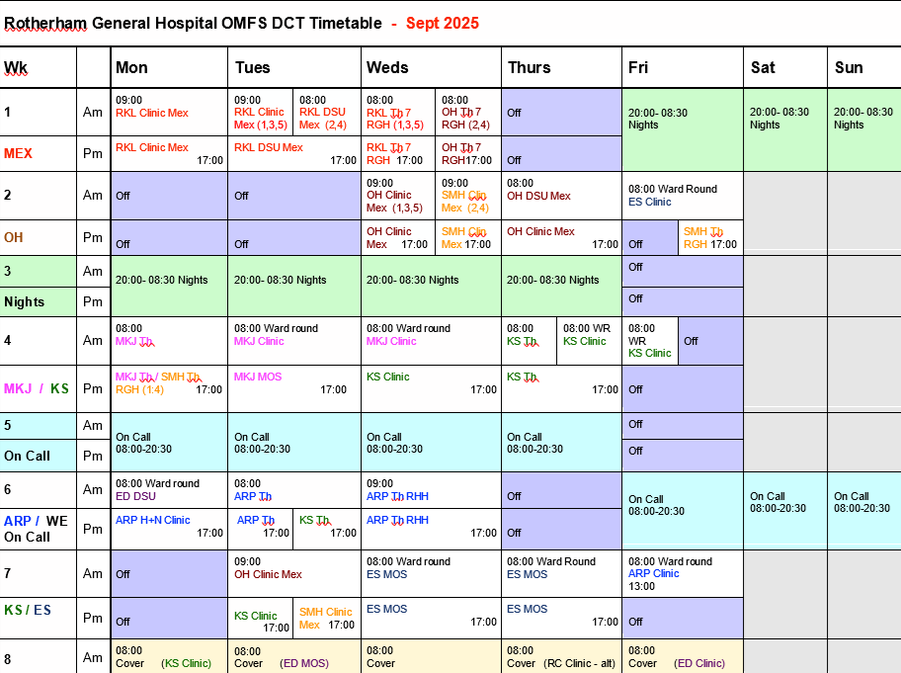

“The DCT post in maxillofacial surgery at Rotherham General Hospital is a fantastic opportunity for all clinicians regardless of their experience. It is a well-rounded mix of oral surgery and maxillofacial surgery that will leave you with increased confidence in the management of complex patients. Due to the nature of the post, you will find that your time management skills greatly improve. The on-call component of the job ensures that you learn to cope with pressure, and will enhance your skills in managing both dental and medical emergencies.
The rota is divided so that you will get time in clinic, in theatre as well as on call. The consultants and staff are kind and supportive. They wish nothing more than for you to succeed as a DCT. If you have any concerns they are listened to, and resolved promptly. I could not recommend this post more.”
Testimonial- Oliver Ryder DCT1 2022/23

Working as a DCT in OMFS at Rotherham Hospital has significantly enhanced my clinical skills with vast hands-on experience available in dentoalveolar surgery in particular. The consultants are all very willing to teach and help us develop as well-rounded clinicians. I would highly recommend this post, particularly to recently graduated dentists looking to further their clinical abilities and confidence.
Testimonial- Darhan Tank DCT1 2023/24

