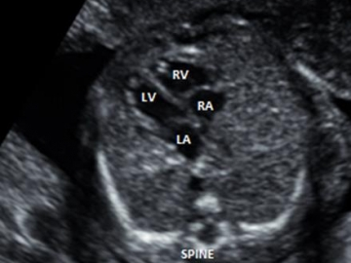
DRAFT: Care in Pregnancy of Mothers and Babies with Congenital Heart Disease
Friday November 5th 2021 09:30-12:30hrs via Microsoft Teams
The Yorkshire and Humber Congenital Heart Disease Network is facilitating a virtual education session which aims to support Obstetricians, Midwives, Obstetric Sonographers and Screening Coordinators with the management of pregnancies in which either the mother or the baby has congenital heart disease.
09:00-09:10hrs | Introduction | Dr Kate English, ACHD Cardiologist
09:10-09:30hrs | Risk stratification of women with congenital heart disease: Pregnancy Care Guideline for Women in Yorkshire & Humber Network with known Congenital Heart Disease | Dr Kate English, ACHD Cardiologist Leeds Teaching Hospitals NHS Trust
09:30-09:50hrs  09.50-10:15am  10.00-10.35am | Local management of the low and moderate risk woman  Management of unexpected admission and delivery of high risk women  Obstetric & Anaesthetic issues | Dr Matt Balerdi, ACHD Cardiologist Hull University Teaching Hospitals NHS Trust  Dr James Oliver, ACHD Cardiologist Leeds Teaching Hospitals NHS Trust  Dr Sarah Winfield , Consultant Obstetrician  Dr Tiff Halsey , Consultant Anaesthetist
10.35-40 | Break
10.40-11am  11am-11.20am  11.20-11.40am | National antenatal detection rates: the National Congenital Heart Disease Audit  Yorkshire and Humber antenatal detection rates: local audit results  Referral Criteria & information about the Fetal Cardiology service | Dr Shuba Barwick, Fetal Cardiologist Leeds Teaching Hospitals NHS Trust  Dr Leila Rittey, Paediatric Cardiology Registrar  Jan Forster, Specialist Sonographer & Marie Wray, Clinical Nurse Specialist Leeds Teaching Hospitals NHS Trust
11.40-12.00pm  12.00-12.20pm | Place of delivery for neonates with congenital heart disease guideline  Management of the neonate with CHD in the delivery suite | Dr Lawrence Miall Consultant Neonatologist Leeds Teaching Hospitals NHS Trust  Rachel Toone
Finish | Evaluation
To register for this event, please email Natalie Machnik, Network Administrator natalie.machnik@nhs.net

