JOB DESCRIPTION

Job Title: | Leadership Fellow – Maternity Improvement
Pay Band: | N/A
Hours of Work: | 37.5 hours per week
Responsible to: | Obstetric Clinical Lead, South Yorkshire Local Maternity and Neonatal System
Accountable to: | Programme Lead, South Yorkshire Local Maternity and Neonatal System
Location: | 722 Prince of Wales Road, Sheffield (with flexible / hybrid working)

Our Values and Behavioural Expectations

We are… | One Team | Empowered | Innovative
Behaviours | We are collaborative, creating solutions with our colleagues, communities and partners. | We are supportive, encouraging each other to reach our full potential. | We are bold, creatively exploring new ways of working and thinking to achieve our goals.
Behaviours | We are open, honest, and authentic with each other. | We are inclusive, embracing diversity and ensuring fairness and equity. | We learn, from our experience and the good practice of others.
Behaviours | We are accountable, holding each other and ourselves to high standards. | We are compassionate, caring, and respectful. | We share, as we lead by example and spread learning within our communities.

About the South Yorkshire Local Maternity and Neonatal System
The South Yorkshire and Bassetlaw Integrated Care System (SYB ICS) recently became the South Yorkshire Integrated Care Board (SY ICB) and will be closely aligned with the South Yorkshire Health and Care Partnership (SY HCP). The ICB will be part of a wider integrated care partnership alongside Local Authorities, Public Health, the Voluntary Community and Enterprise Sector (VCSE), Primary Care and NHS provider organisations, aiming to support communities to lead happier, healthier lives.
These changes offer a variety of opportunities for organisations within the NHS, and system partners, to work more collaboratively in the planning and delivery of services to tackle health inequalities and improve quality and outcomes.
The Local Maternity and Neonatal System (LMNS) is the maternity aspect of the ICB and is mandated to deliver the national Maternity Transformation Programme and the recommendations of the Better Births and Ockenden reports. We are working with all our partners, service users and parents to improve maternity services for the women and babies of Barnsley, Bassetlaw, Doncaster, Rotherham and Sheffield.
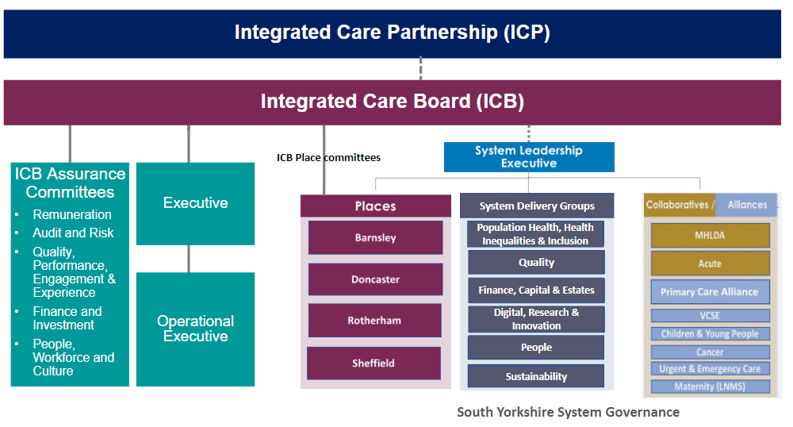
Maternity services for South Yorkshire citizens are provided by the following NHS Trusts:
- Barnsley Hospital NHS Foundation Trust (BNHFT)
- Doncaster and Bassetlaw Teaching Hospitals NHS Foundation Trust (DBTHFT)
- The Rotherham NHS Foundation Trust (TRFT)
- Sheffield Teaching Hospitals NHS Foundation Trust (STHFT)
Job Summary

The South Yorkshire Local Maternity and Neonatal System PMO team are committed to transforming and improving services for women, birthing people and their babies in the face of system-wide challenges.

During the post, the Leadership Fellow will play a vital role in supporting this work and delivering on the commitment to make sure everyone gets the best start in life (NHS Long-Term Plan).

Taking a system-wide approach and collaborating with colleagues from all four Trusts, the Leadership Fellow will support improvements that positively impact health determinants and outcomes for women, birthing people and babies across South Yorkshire. The post-holder will have the opportunity to take the lead on an exciting quality improvement project relating to an area of personal interest.

The successful post holder will spend 50% of their time on project-specific work, and the other 50% on personal development and training.

The post-holder will:
- Lead a quality improvement project in collaboration with teams across South Yorkshire, focused within one of the LMNS’ key workstreams and an area of particular interest to them.

The LMNS’ broader workstreams include:
- Workforce Development
- Prevention (healthy lifestyle, smoking cessation, vaccinations in pregnancy, among others)
- Safety and Assurance (off-pathway births, MDT training, among others)
- Equity and Equality
- Personalisation and Choice
- Digital.

- Work with their supervisor, the Obstetric Clinical Lead, SY LMNS, and the Programme Lead to identify a project focus, ensuring a SMART approach.

- Co-produce initiatives and improvements that place women, birthing people and their babies at the heart of our maternity services.

- Develop relationships with key stakeholders from all four Trusts as well as external organisations such as local authorities to enable the successful delivery of the project.

- Provide strategic input and influence at key decision-making and governance meetings and groups relevant to the project / workstream and their area of interest.

- Join the Yorkshire and Humber Clinical Network and / or Neonatal Operational Delivery Network, depending on their area of interest, contributing to discussions and decisions around maternity transformation.

- Share and implement learning from their training and development with colleagues across the system through their project and interactions, building the capability of the wider workforce.

The organisation will:

- Ensure the successful post-holder has the opportunity to develop and deliver a quality improvement project within a workstream that is of particular interest to them and has the autonomy to set their own goals and objectives within the scope of the project.

- Ensure the post-holder is supported to develop and hone the skills needed to embark on a successful career in leadership within the NHS.

- Ensure the post-holder is supported in their development by the Obstetric Clinical Lead and LMNS Programme Lead as well as the Senior Responsible Officer (SRO) for the programme.

- Support them to attend and undertake additional training related to their project and area of interest wherever possible.

- Ensure the post-holder is provided the opportunity to engage and be involved in key decision-making processes and governance structures, such as the LMNS Collaborative Board.

- Ensure the post-holder is provided the opportunity to build networks and engage with both internal and external stakeholders, collaborators and partners.

Organisation Chart

Senior Responsible Officer

Programme Director / Lead (8D)

Obstetric Clinical Lead

Midwifery Clinical Lead (8B)

Senior Information Analyst (6)
Transformation Lead (8A)
Leadership Fellow (this post)

Project Support Officer (5)

Main Duties and Responsibilities
- Communication and relationships

- Develop relationships with key stakeholders across the LMNS, including Heads of Midwifery, Lead Midwives, Obstetric and Midwifery colleagues, service users and partners, among others.

- Provide strategic input at key decision-making and governance meetings and groups relevant to the project / workstream and their area of interest, including engaging with senior colleagues.

- Developed communication skills for delivering key messages to a range of stakeholders both internal and external, some at a very senior level.

- Able to work effectively as part of the wider LMNS team.

- Analytical and judgement

- Ability to analyse and make judgements on the progress of the project, identifying and escalating issues or risks through the appropriate governance channels, as well as suggesting mitigating actions.

- Planning and organisation

- Use their knowledge and understanding of basic project management and quality improvement principles to determine and plan key deadlines and milestones in the project lifecycle, as well as identifying key actions and interdependencies.

- Able to plan and manage their own workload, balancing training and professional development with the demands of the project.

- Patient/Client Care

- Co-produce initiatives and improvements that place women, birthing people and their babies at the heart of our maternity services.

- Mental Effort

- Ability to balance conflicting priorities, such as training and personal development with the demands of the project.

- Working Conditions

- Remote / hybrid working.

General

The post holder will:

- Develop a culture that promotes equality and values diversity. The post holder must be aware of and committed to the Equality and Diversity policies of NHS South Yorkshire ICB, comply with all the requirements of these policies and also actively promote Equality and Diversity issues relevant to the post.

- Ensure the principles of openness, transparency and candour are observed and upheld in all working practices.

- Ensure that any infection prevention and control issues are reported to their line manager/Infection Prevention and Control.

- Be aware of and adhere to the provisions of the Health and Safety at Work Act and to ensure their own safety and the safety of colleagues and patients.

- Maintain confidentiality at all times.

- Comply with mandatory training requirements and ensure that adult safeguarding is embedded as an essential part of their daily practice. Safeguarding is everyone’s business and staff within the organisation have a particular responsibility to ensure all safeguarding concerns are responded to effectively and efficiently in accordance with the local Safeguarding Adults Board Policy and Procedure.

- Ensure that their actions support the aim of the organisation in ensuring that all children up to the age of 18 years are protected from significant harm, abuse and neglect, within the framework of multi-agency Child Protection services established in the Guidelines and Procedures issued by the Area Child Protection Committee.

- Ensure that their actions support the aim of the organisation in ensuring that all vulnerable adults are protected from significant harm, abuse and neglect, within the framework No Secrets which provides guidance on developing and implementing multi-agency policies and procedures to protect adults "at risk".

- All staff must follow their professional Code of Conduct where relevant, e.g., NMC, GMC, CMIPD, CMIOSH.

- All managers are expected to follow the NHS Managers Code of Conduct

- This job description is not meant to be exhaustive. It describes the main duties and responsibilities of the post. It may be subject to change in light of developing organisational and service needs and wherever possible change will follow consultation with the post holder.

PERSON SPECIFICATION

ASSESSMENT CRITERIA | Essential | Desirable
Qualifications and Experience
Specialty Trainee: ST3+ / AfC Band 6 (or higher) NHS Healthcare Professional, including nurses and midwives | X
Current registration with relevant professional body | X
Evidence of participation in CPD in the last 12 months | X
Have Head of School approval for a year out of programme / agreement from current employer to undertake a secondment | X
Full understanding of and good standing with appropriate professional body |  | X
Knowledge and Understanding
Understanding of basic quality improvement and project management principles, including stakeholder engagement | X
Basic understanding of co-production and stakeholder engagement |  | X
Knowledge and understanding of clinical governance | X
Understanding of basic audit principles, risk management and evidence-based practice | X
Understand issues relating to equality and diversity and how this impacts on the NHS agenda | X
Skills and Competencies
Excellent interpersonal skills and ability to build relationships with colleagues at all levels | X
Excellent verbal and written communication skills, including the ability to communicate complex information to a wide-ranging audience | X
Competent in using MS Office packages including Excel, Word, PowerPoint | X
Able to support and develop others | X
Attributes
Good time management and organisation skills | X
Demonstrates behaviours consistent with the ICB and FLP values | X
Able to work effectively as part of a team or independently | X

Date Last Reviewed: | 23/08/2022 | By: | Tracy Hoggarth
Date Banding Approved: | N/A | By: | N/A

