**ALM Applicant User Guide**

Applying for Study Leave

**Accent Leave Manager (ALM)**

**All study leave applications from doctors (except FY1) and dentists in training within Yorkshire and the Humber must be submitted using** [**Accent Leave Manager**](https://accent.hicom.co.uk/Portal/Live/Web/)**. Please carefully read this guide before applying for study leave.**

**Paper application forms are not required and are no longer accepted when requesting reimbursement of study leave expenses.**

**It is important that you also familarise yourself with the Study Leave Policy, Operational Guidance and other resources on** [**our website**](https://www.yorksandhumberdeanery.nhs.uk/professional-support/policies/study-leave/)**.**

Contents

Activating your account

Approval stages

Submitting an application

Claiming expenses

Support contacts

### Activating your account

ALM accounts are created automatically and you should receive an activation email 8 weeks before your programme start date. If you have not received the activation email, you can activate your account using the forgotten password link on the [login page](https://accent.hicom.co.uk/Portal/Live/Web/).

Your ALM username is the email address held in the NHSE Trainee Information System (TIS). From 2023 new starters can look up the details held for them by NHSE using TIS Self-Service: <https://trainee.tis-selfservice.nhs.uk/>

To change your email address, please submit a request using TIS Self-Service or contact your [PGMDE School](https://www.yorksandhumberdeanery.nhs.uk/contact-us). Instructions for TIS Self-Service will have been sent to you by your PGMDE school.

Please note: ALM is not optimised for mobile browsers and some essential sections of the application screen do not function on mobile devices. Please ensure that you access ALM using a desktop/laptop computer and either the Chrome, Edge, Safari, or Firefox browser.

### Approval stages

Study Leave approval involves three stages. The first two stages are completed outside of Accent Leave Manager.

**Rota Coordinator** approval for the time off using the local trust process or electronic rota must be secured before applying for study leave on ALM. Rota Coordinator approval must be requested at least 8 weeks before the event.

**Supervisor** approval for the educational appropriateness of the course/conference must also be given before an application is submitted on ALM. This may be discussed as part of PDP planning or later and documented as appropriate on your e-portfolio.

Once Rota Coordinator and Supervisor approval have been confirmed, a Study Leave application may be submitted on ALM for final **Training Programme Director** approval. Alternatively, where a course/conference is pre-approved by the PGMDE school, the application will be routed in ALM to Medical Education for approval.

**Expense claims** are authorised after the event by Medical Education. Expense claims are submitted using the trust expenses system. Before authorising your claim, Medical Education will check your claim against your application on ALM.

### Submitting an application

To create a new application on ALM, click *Leave* Application in the Navigation Menu.

##### Leave details

Begin by entering the initial leave details and checking the placement information displayed.

* *Start/end date* – If the dates span two placements, separate applications will be needed.
* *Number of days* – This can be adjusted if necessary, eg to reflect half-day courses or if the activity is taking place outside of work time and you do not intend to claim TOIL.
* *Leave type* – Please ensure you select the appropriate leave type. NB: Exam includes exam preparation courses and exam sittings.

If you see the error message ‘There are no approvers available for this placement, please select different dates or placement’, please contact [studyleave.yh@hee.nhs.uk](mailto:studyleave.yh@hee.nhs.uk), and include the dates for which you are attempting to apply in your email.

If you see the error message ‘No placements found for selected dates’, this may mean that your placement has not yet been added to the NHSE Trainee Information System. Placements are added to TIS 8 weeks before the placement / rotation start date. If your placement is missing, you may need to contact your [PGMDE school](https://www.yorksandhumberdeanery.nhs.uk/faculty/contact-us). Please avoid contacting the school until you are within 8 weeks of the placement / rotation start date.

##### Event details

On the next page please enter the details for the activity for which you are applying.

* Event – The event list includes pre-approved activity related to your programme / grade.

Otherwise, click the toggle if your “event does not appear in the list above” and enter:

* Event name – The name of the course / conference / exam. If possible, avoid acronyms.
* Course reference – Not mandatory. The course reference used by the provider.
* Venue – The venue where the activity is taking place. For virtual course/conferences
* enter ‘online event’ or ‘online self-paced course’ as applicable.
* Website – Enter a link to the event webpage where the approver can find more information about the course / conference.

Pre-approved activity includes **Regional Teaching**. Regional teaching is a study / clinical skills day organised by your training programme, or a school conference. As a general rule, regional teaching does not have a course/conference fee. Please only select regional teaching if the course / conference is organised by your training programme. For **all external course / conferences** please either select the specific event from the list or enter the event name in the free text box below.

##### Entitlements and Budget

ALM will display a summary of your study leave entitlement and budget on the application screen. Entitlement refers to the number of study leave days allocated to doctors and dentists in training. Your entitlement includes mandatory and regional teaching study days.

Budget refers to the costs of your study leave applications to date. On ALM your budget amount/remaining budget reads ‘unlimited’, but it is important to note that while individual study leave caps no longer apply, the overall study budget is finite. All applications are evaluated based on their educational appropriateness, quality and value for money.

Entitlements and budgets are calculated based on the financial (rather than academic) year and are imported by the Study Leave admin team. If you see the error message ‘No entitlements/budgets found for selected data’, please contact [studyleave.yh@hee.nhs.uk](mailto:studyleave.yh@hee.nhs.uk).

##### Cover & authorisation

Rota Coordinator and Supervisor approval are required before submitting an application on ALM (see the Approval Stages section above). The name of the Educational Supervisor (or A screenshot of a computer
Clinical Supervisor in some specialties) and Rota Manager (or Coordinator) who have approved the time off / activity should be entered in the cover & authorisation section.

The comments box in this section is for additional comments re Supervisor and Rota Coordinator approval. Additional comments re the course/conference are not required here.

This section and the declaration must only be completed if Supervisor and Rota Coordinator approval has been received. If you are still waiting for Supervisor and or Rota Coordinator approval, please save your application as a draft and continue when they have confirmed.

Where an application has been submitted but Rota Coordinator approval has not been received, the trust may decline to release the applicant for the course/conference. Late or retrospective leave requests are considered at the discretion of the trust.

##### Expenses

If you intend to claim expenses for the course/conference, estimated expenses must be added to your application before it is submitted. Expenses cannot be added after an application has been submitted.

Expense claims, which are submitted after the event, will only be processed, if estimated expenses were added at the time of application and the application was approved.

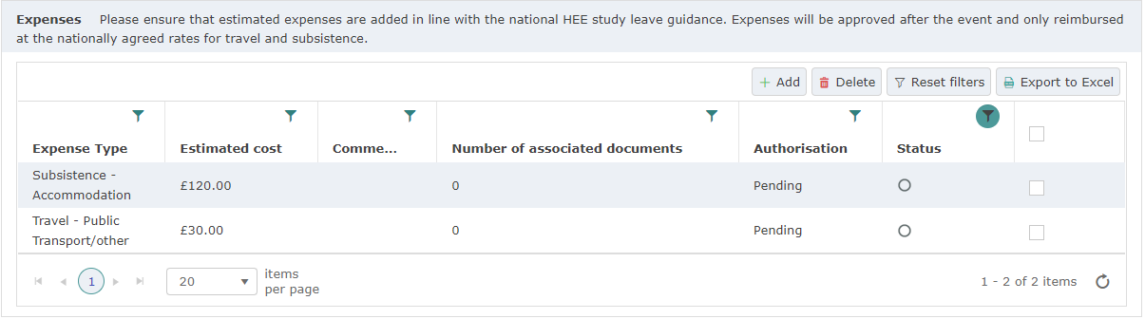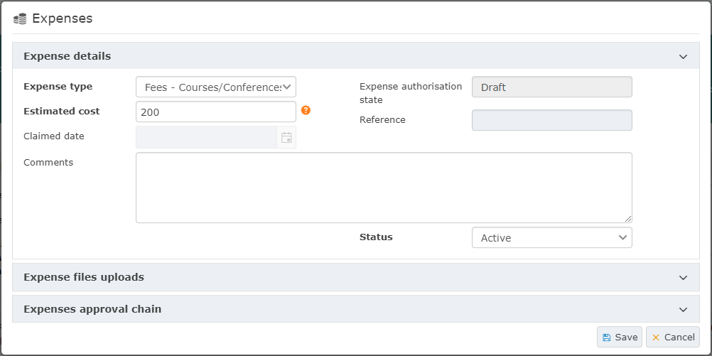

To add an estimated expense, click Add in the Expenses section. Then select the Expense Type and enter the Estimated Cost and click Save. Study leave expenses may include:

* Course conference fees – This does not include membership or exam fees which cannot be claimed as study leave expenses.
* Travel – Milage or public transport costs. Public transport is only reimbursed at the cost of a standard class ticket.
* Subsistence - Lunch or overnight meal allowance may only be claimed if away from base or home and may only be claimed where catering is not provided.
* Accommodation – may be claimed when required due to the location of the course/conference. The most cost-efficient accommodation option must be chosen.

Allowances for travel subsistence and accommodation expenses are outlined in the [Study Leave Operational Policy](https://www.yorksandhumberdeanery.nhs.uk/professional-support/policies/study-leave/). Estimated expenses must be within the allowances and will only be reimbursed after the event in line with the nationally agreed rates.

##### Submit leave application

Once you have completed and checked all the sections, click submit leave application. When you click submit, you will be asked to select the relevant Training Programme Director for your placement at the time of the leave. If your application is for a pre-approved course/conference, it will be routed to Medical Education for approval.

If the TPD for your placement at the time of the leave is not listed or if your application is routed to the wrong TPD. Please contact Medical Education or [studyleave.yh@hee.nhs.uk](mailto:studyleave.yh@hee.nhs.uk).

If you are not ready to submit your application, you can Save your application as a draft to enable you to return to it later.

To view your submitted and saved applications, go to My Applications in the Navigation Menu. The dashboard will show the approval status of all your submitted applications.

### Cancelling an application

If you need to cancel an application, you can do so before the date of course/conference. To cancel an application, find and open the application in My Applications and click cancel at the bottom of the page. Cancellation requests are routed to Medical Education for approval.

If the course/conference date has passed, please contact Medical Education to ask for your application to be cancelled.

If you are not able to attend a course/conference for which you have applied or the event is cancelled, cancelling the application helps to ensure that your entitlement days and budget are record correctly.

### Claiming expenses

While study leave applications are now submitted using Accent, reimbursement continues to be through the local trust expenses system. Expense systems vary depending on the employing trust, please contact Medical Education at your employing trust for information about or assistance using the trust expenses system. (See below for contacts.)

Expense claims may only be submitted after the course/conference and must be submitted within 6 weeks of the event. Late claims are considered at the discretion of the trust.

Expense claims will only be reimbursed if a Study Leave application with estimated expenses was submitted on ALM and approved in advance of the event.

### Support contacts

**For assistance using ALM or claiming expenses**, please contact the Medical Education Centre at your employing trust. Medical Education contacts are listed on [our website](https://www.yorksandhumberdeanery.nhs.uk/professional-support/policies/study-leave). Alternatively, please see the trust directory.

**To follow-up outstanding approvals**, please email the approver in the first instance. Please allow approvers 14 days to approve/decline your application before emailing. If you do not receive a reply, please contact Medical Education or the NHSE Study Leave team.

**For technical support, feedback or guidance**, please contact the NHSE Study Leave team at [studyleave.yh@hee.nhs.uk](mailto:studyleave.yh@hee.nhs.uk). NB: The study leave team can advise on the central policy and process, funding queries about specific events should be directed to your TPD.