Rehna

Khan
Executive Coaching

How do I know if coaching is right for me?

- Do you feel that currently you aren’t reaching your potential and feeling fulfilled?

- Is there a gap of where you are now to where you want to be?

- Do you sometimes feel you don’t have the skills, resources or confidence to get something complete?

- Do you feel stuck and put off making decisions or fail to stick to those decisions you have made?

- Are you ready to entertain new and fresh ideas?

- Are you willing to be accountable for what you desire?

- If you answer YES to any of these questions then coaching can most definitely support you to be the best that you can be.
Profile  A trained executive coach and an experienced Ophthalmology Consultant working in both the NHS, medical education and the private sector.  She has been teaching and mentoring junior doctors for 18 years within the N.H.S and appraising peers and senior colleagues. She also has an active role on the exams committee at the Royal College of ophthalmologists. She has had many leadership positions including principal investigator on national research trials and board member of the North of England Ophthalmological Society and the Yorkshire Retina Society.  A summary of her C.V. can be found online at Optegra “meet our consultants”  I believe I am well placed to champion clients who wish to “thrive despite pressure” of work. I am passionate about helping colleagues achieve more. My ethos is “every person is capable of achieving far more than they think they can…and coaching can help you get results faster than if you try to solve it all alone”  Rehna is the founder of “Success with Grace TM” a virtual workshop that provides tools to individuals to achieve more at work without sacrificing their health and family”  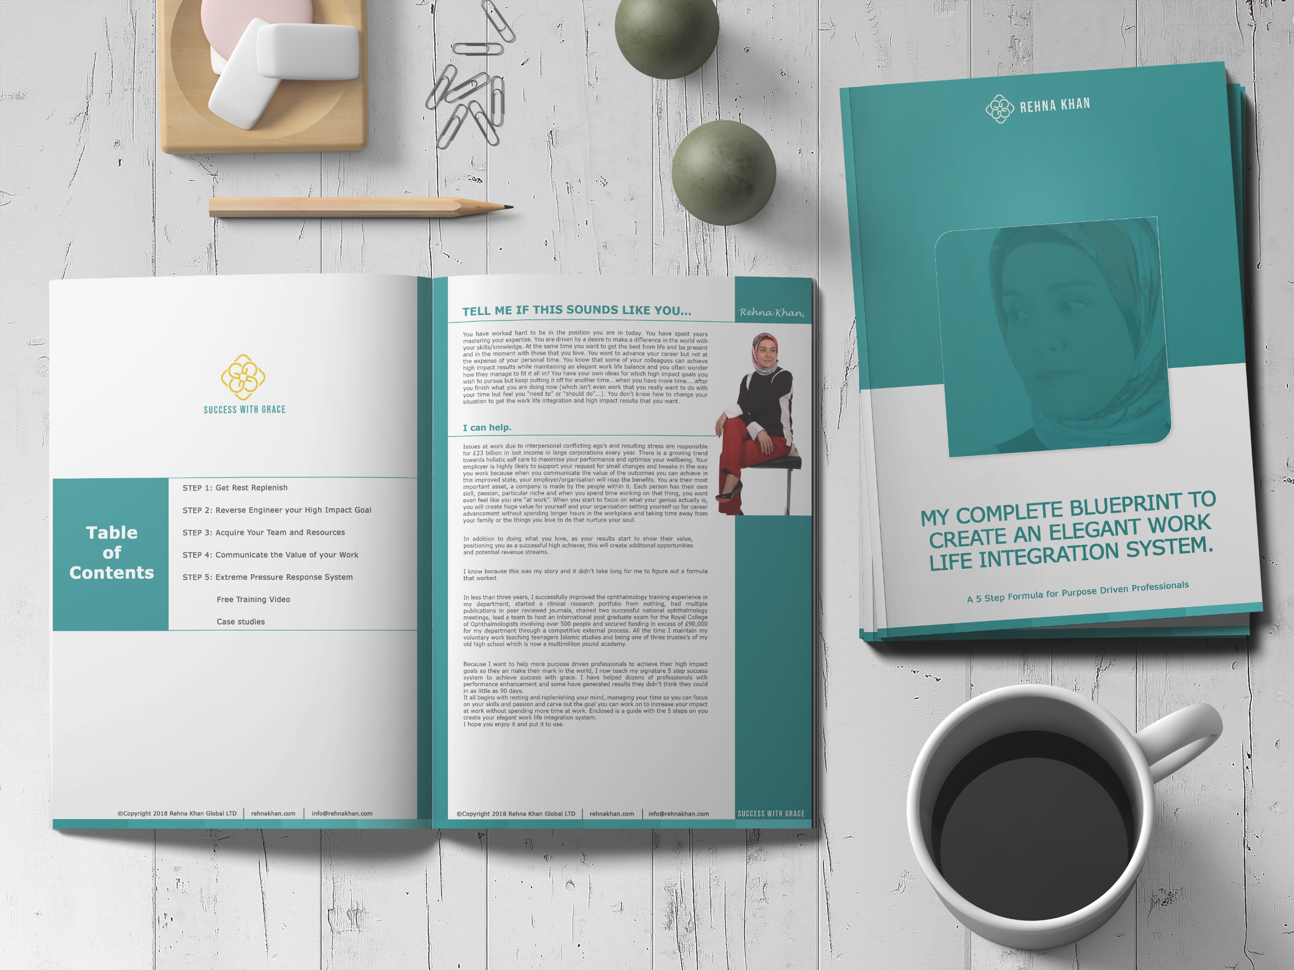  MY COACHING STYLE  Enabling, Motivating and Inspirational.  I use a range of evidence based coaching tools.  It is not for those who don’t wish to try! The process can deliver life changing results and the clients that get the best results are those that are really present.  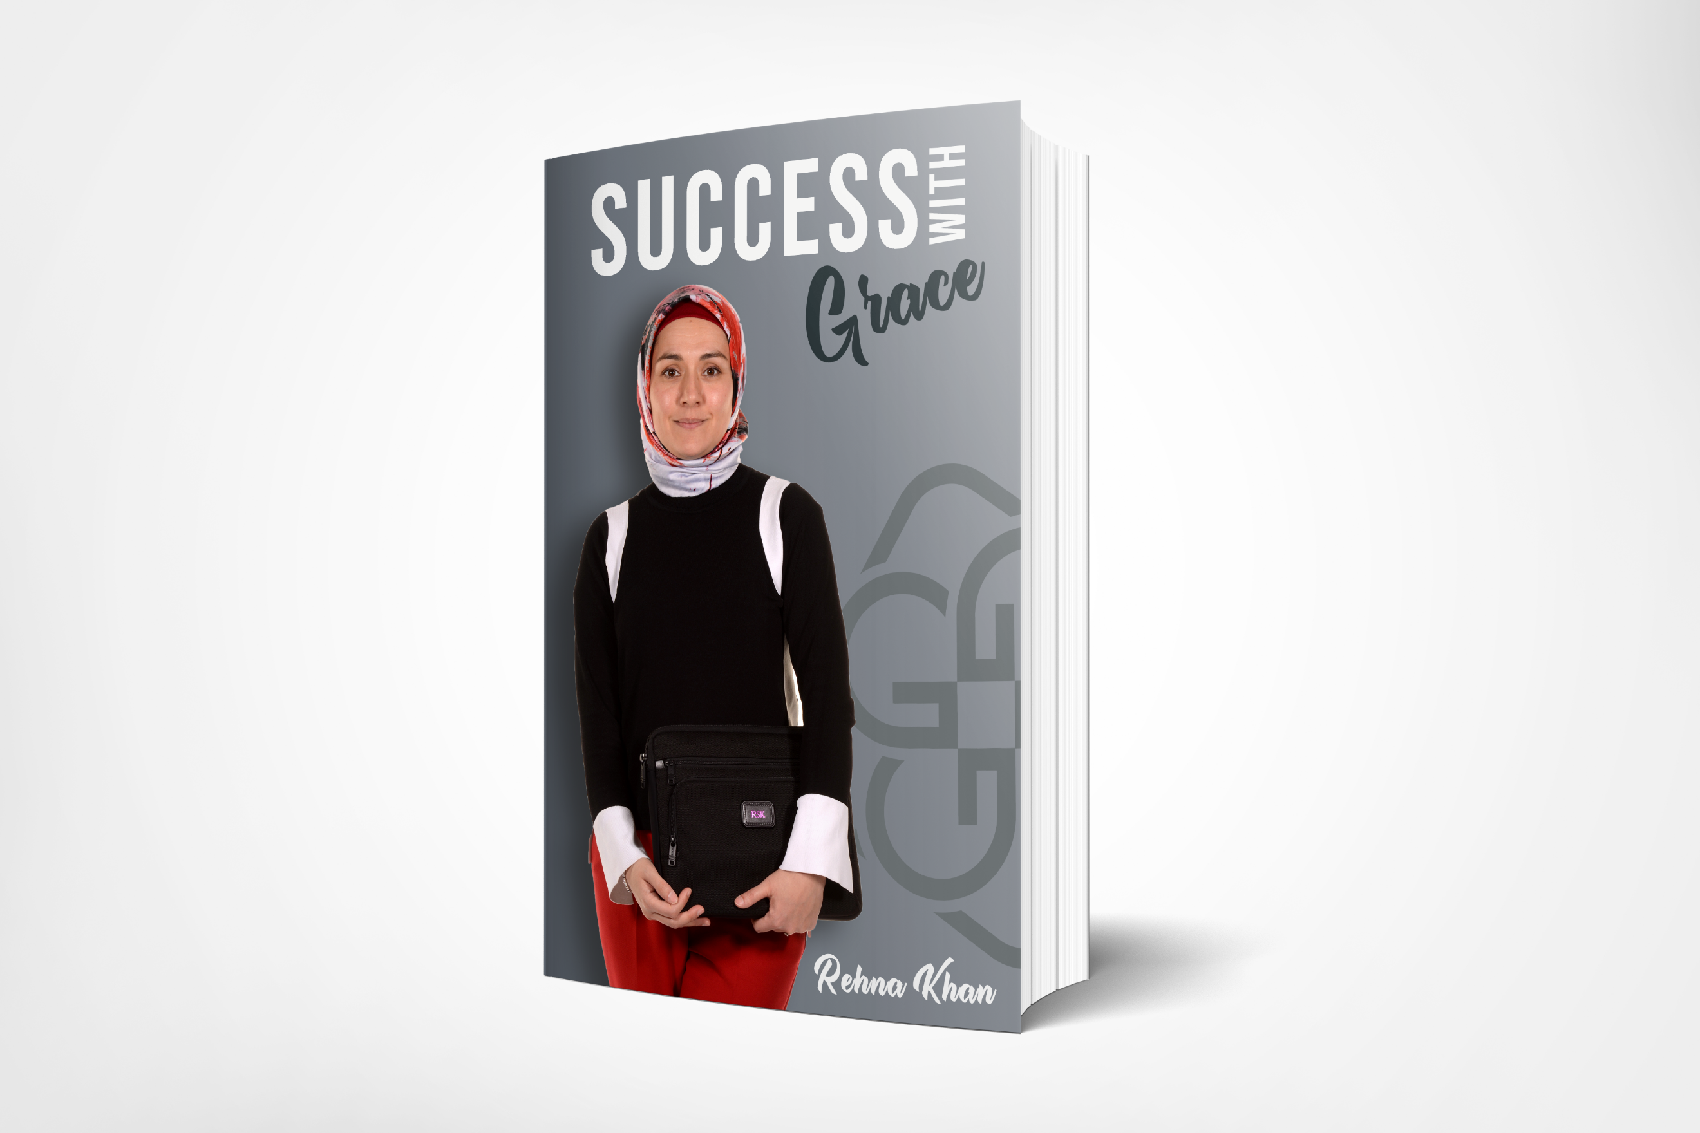  “What we do today affects the reality of our tomorrow”  CONTACT  EMAIL:  rehnakhan@doctors.org.uk |  | What coaching is not  Coaching is not about your coach giving you suggestions or advice. They are not mentoring or counselling you.  If you commence a series of coaching sessions and it is deemed that coaching is not the correct support mechanism for you at this moment in time this will be discussed with you directly to find a suitable solution to support your onward journey.  How does coaching work?  Different coaches use different models to structure their sessions. A popular model is the GROW model which is an acronym for the areas explored, Goals, Reality, Options and Way forward.  This model keeps you moving forward towards your goal. Your coach will be asking you questions, listening to your responses, challenging you whilst all the time remaining non-judgemental regarding the details and not offering you any advice.  What will happen during a coaching session?  Coaching is predominantly carried out via Zoom. All you need is an internet connection/wifi, a smart phone/access to a screen. After arranging a convenient time and date via email you will be sent the free link to download.  You will be guided through a 6 point process.  1. Review the previous session and the actions that you completed (if relevant)  2. Set the goal for that session  3. Consider where you are at the present moment with this goal  4. Consider your options in meeting this goal  5. Agree on some actions  6. Summarise the session before completing the session.  Each session will be for 40 minutes. The coach will manage the timing of the session and ensure you gain full value from the session. You are encouraged to take your own notes especially with regard to action points.  Who else will know what has been said?  A coaching session is completely confidential. I agree and comply to the Coaching Code of Conduct which you will find attached in your new client welcome pack (emailed to you on signing up) and only in extreme circumstances will this confidence be breached. This includes the intent to cause harm to yourself or others or criminal acts.  What does the coach need from me during a session?  To make sure that your time is being well spent with your coach you are expected to come to the session fully prepared and with a goal or aspiration in mind that you would like to work towards.  Preparation is very important for the coaching session so you are encouraged to spend 15 minutes prior to the session taking yourself to an environment where you will not be disturbed, with a drink and feeling refreshed to relax prior to the start of the session. You will also need to ensure that you have a pen and paper to hand and any other items that you may think will be useful such as a diary.  Permission to challenge or use silences  During our coaching sessions, my focus is on YOUR GOALS and finding ways to support YOU to articulate your goals, unpack the reality of your situation and by asking you questions, give you a supportive framework within which to move from where you are now to where you would like to be. This may require me to challenge the way you present information and ask you to reframe things, or look at the same thing in a slightly different way.  I want to start coaching now. What do I do?  You just need to contact me via email (see below) to discuss your requirements in a little more depth and find out how you would like to be coached.  I will send details through regarding the terms and conditions which will include the frequency of our sessions, taking of some basic contact information and a little bit of detail around where you see yourself at the moment.  I want to start coaching and I would like to know the cost of the sessions…  Executive coaching can cost from £120-300 per hour. The cost of these sessions is being funded by my company Oculus Dexter Ltd. We are working to ensure the coaching delivers benefit and in exchange for feedback and your true, honest testimonial, there is no charge to you for these sessions. We only have a limited number of these funded sessions so book now to avoid disappointment.  We would organise an ‘Intake’ session which will start us talking about you and your aspirations.  After all this is all about YOU!  email me at rehnakhan@doctors.org.uk

