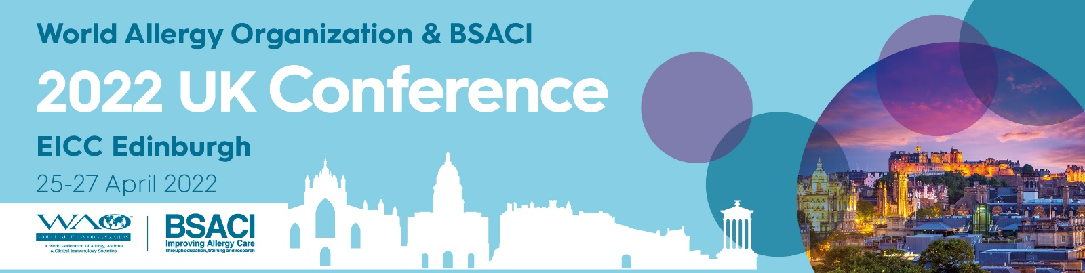

ALLERGY AND CLINICAL IMMUNOLOGY
A YOUNG, EVOLVING AND DYNAMIC SPECIALTY

The British Society for Allergy and Clinical Immunology (BSACI) is offering 10 scholarships for trainees to attend the
WAO & BSACI 2022 UK Conference

Details of the award:

Open to FY2 doctors, IMT and paediatric trainees up to ST3.

Up to £700 to cover conference fees, hotel accommodation
and travel expenses.

The application involves a 300-word statement detailing why you would benefit from this scholarship with a supporting letter from your current supervisor.

Abstract submission for the conference is encouraged but is not a requirement.

Please note previous recipients may not apply

Deadline: Monday 28th February 2022

Email: marie@bsaci.org Telephone number: 0207 501 3910

To find out more details and to apply visit www.wao-bsaci.org

