Touchstone: You Said, We Did
Welcome to Touchstone, where your voice is an important part of the process in identifying how the Quality Team and Trainee Forum can play a part in improving working lives and how we can collaboratively work together to achieve this goal. It will be a challenge and a commitment to change!! In this section we aim to discuss issues important to you and help you know that as a trainee doctor or dentist ‘Your Voice Matters’ and how your actions can contribute to better training experience for all!
The Trainee Forum and Quality Team are here to listen to your concerns, identify potential resolutions and be transparent on how your engagement can helps us make a difference. The Forum would like to thank the Quality team for working collaboratively to allow transparency & understanding of improvements that can be made to training and the workplace.
Please take time to make the most of this opportunity and to recommend what YOU want to see from Quality by contacting Vicky Jones, Quality Co-ordinator at vicky.jones@hee.nhs.uk.

You Said: Sources of Data Intelligence
There are many ways in which you can put forward your views on your training through the Trust escalation processes, your TPD/College Tutor, Training Surveys and Learner/Educator Interventions. The purpose of Quality is to triangulate the data, discuss concerns with providers to identify actions to support you.
Surveys: are one of the many powerful tools we can use to collate information which informs the majority of work that HEE and the Quality Team do. The two main surveys we use to understand where concerns are arising or identify where sustained changes can be assessed are:
- GMC NTS Survey – this is an annual survey normally in March/April each year, with the 2021 Reporting Tool now available and keep watching for the 2022 information.

- National Education and Training Survey – this is a bi-annual survey in June and November each year, with the June 2021 data currently being analysed. This is a multiprofessional survey which allows for voices to be heard across the learning spectrum to allow us to triangulate concerns in a more cohesive way.
Both surveys are very important and by submitting your views we can work on change.
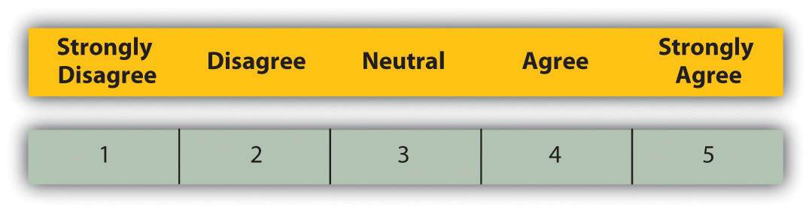

What do we do with your data?
HEEs first steps are to investigate these concerns and gather more evidence, which we do by engaging Heads of Schools, TPDs and DMEs through either direct immediate contact or at regular monitoring of the learning environment meetings. Additional feedback from trainees themselves can be sought by holding a learner educator review, resulting in obtaining a more robust picture of the issues and discuss effective action plans for improvement.
Trainees are vital part of the Quality Teams work, as You know your training experience best and have often already thought of constructive ways to contribute to these concerns being amicably resolved.
This Photo by Unknown Author is licensed under CC BY-SA

We Did – How has training improved?
In this area we would like to give you examples of where you as trainees have identified a concern, how we taken this forward and actions from it. This is ongoing and watch for further additions. If you have a concern – please let the Quality Team or Trainee Forum know – people do listen
Rotherham, Doncaster and South Humber Mental Health Trust
What was identified: following reviews and feedback through both the NTS and NETs survey indicators suggested that a Programme Review of Foundation Psychiatry across the regions would be beneficial with both Trainers and Trainees to have open discussions about any rising concerns. As part of this review reports emerged within the Trust of levels of adequate supervision not being available for a sustained period following the departure of a consultant, with remaining Consultants being overstretched, though there were no reports of patient safety concerns.
Initial Trust Action: Concerns were escalated to the Associate Medical Director and Director of Postgraduate Medical Education (DME) who, following discussions with senior colleagues agreed the delivery of improved support and supervision for the new intake of FYs from April 2021. The plan included a dedicated consultant presence on the wards every day to allow for better consistency day to day and additional support to the FYs. The FPTPD was asked to check on the wellbeing and progress of the trainee who reported concerns and this was successfully carried out. The DME met with the new intake to share the concerns of the previous FYs and actions subsequently implemented and ensured the FYs knew how to escalate any concerns about their training. The deputy DME also maintained regular contact with the trainees to monitor their experience and to identify any concerns at an early stage. Through this closer engagement and discussions with trainees’ feedback indicated that these have been well-received measures in taking forward views for change. A new Consultant starts in August, alongside a new middle grade doctor for the unit, and adjustments to supervision arrangements have been seen as a positive way forward. The unit is also seeking to recruit an Advanced Clinical Practitioner.
HEE Actions: As part of our supportive measures regular contact was maintained with the Trust Teams to assess progress against the recommendations of the review and to ensure that all voices were being heard. With the involvement of the Head of School a Monitoring the Learning Environment was held to establish whether the supportive actions put in place were having the expected impact, review any further measures and how to ensure sustainability of the actions. Further meetings are expected to take place to ensure that both current and new starters are well informed of how they can put forward to establish a consistent established change.
HEE would like to thank the Trust for allowing the use of this example.

