Fetal Blood Sampling Model

Materials:

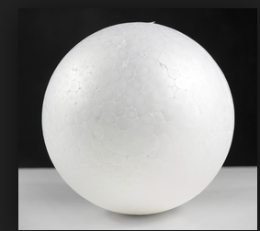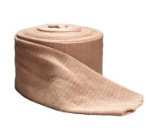
Polystyrene ball 7-10cm (cheap online) Tubular bandage

Fake blood/Food colouring
Detergent
Gloves

Instructions:
- Wrap the polystyrene ball in one layer of tubular bandage.
- Insert ball and bandage into a glove.
- Mix fake blood/food coloured water with small amount of detergent to thicken.
- Pour blood mixture into glove until completely covered.
- Tie knots in both ends of glove.
- Insert into pelvis

CAUTION: Fake blood/food colouring can stain the PROMPT/Pelvis – use plenty of lubricant on your model and wipe stains immediately

